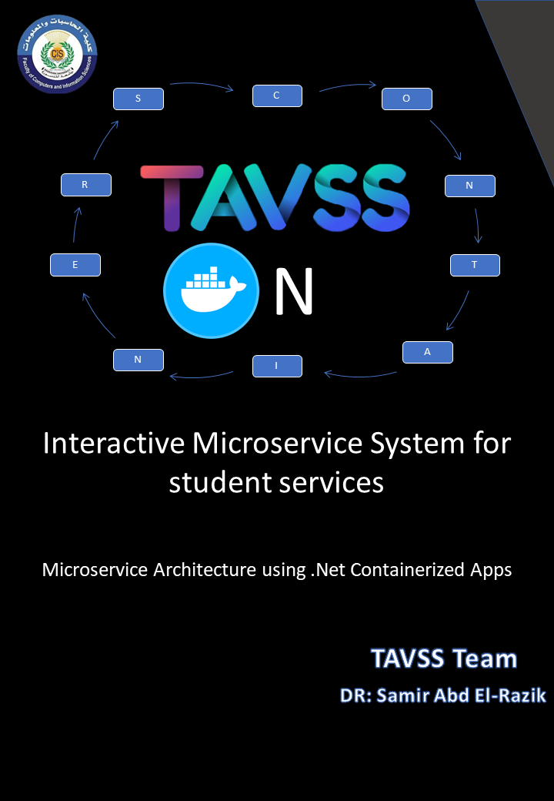



**Edition V 1. 0**

**Published by:**

TAVSS team a division of Mansoura University CIS Faculty team

Copyright © 2019 by TAVSS Team

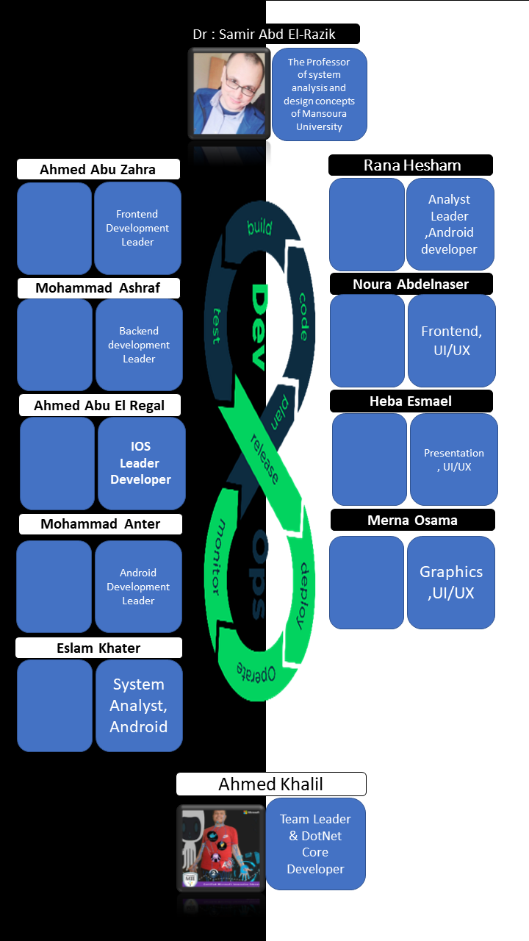

List of Contents

[Chapter 1 : Introduction 8](#_Toc32608170)

[1.1 Defining Services 8](#_Toc32608171)

[1.2 Objectives 9](#_Toc32608172)

[1.3 SWOT Analysis: 10](#_Toc32608173)

[1.4 Internal Vs External Services 12](#_Toc32608174)

[1.5 Dimensions of Solution 13](#_Toc32608175)

[1.6 A traditional model to solve problem 14](#_Toc32608176)

[1.7 The Biggest deals of Architectures {Monolithic vs SOA VS MICROSERVICES} 15](#_Toc32608177)

[1.7.1 Monolith 16](#_Toc32608178)

[1.7.2 A service-oriented architecture (SOA): 16](#_Toc32608179)

[1.7.3 Microservice 16](#_Toc32608180)

[1.7.4 To Go Macro, Go Micro 17](#_Toc32608181)

[1.7.5 Pros and Cons of Architectures: 17](#_Toc32608182)

[1.8 The Plan of The Microservices Development 18](#_Toc32608183)

[1.8.1 How Microservices Improve Agile Development 18](#_Toc32608184)

[1.8.2 The plan decomposition 19](#_Toc32608185)

[1.8.3 Defining The Processes 19](#_Toc32608186)

[1.8.4 Scrum as Agile framework 23](#_Toc32608187)

[1.8.5 The 4 Agile Sprints: 25](#_Toc32608188)

[CHapter 2: Architecture Building 27](#_Toc32608189)

[2.1 Microservice Design Patterns 27](#_Toc32608190)

[2.1.1 Domain Driven Design 27](#_Toc32608191)

[2.1.2 Communication in a microservice architectur 29](#_Toc32608192)

[2.1.2.2 Asynchronous microservice integration enforces microservice’s autonomy 31](#_Toc32608193)

[2.2 What is Docker? 33](#_Toc32608194)

[2.2.1 Introduction to Docker 33](#_Toc32608195)

[2.2.2 why Docker 34](#_Toc32608196)

[2.2.3 Docker terminology 34](#_Toc32608197)

[2.2.4 Docker Orchestration 37](#_Toc32608198)

[2.2.5 Clustering 37](#_Toc32608199)

[2.3 Building Blocks 37](#_Toc32608200)

[2.4 Domain Driven Design Pattern 37](#_Toc32608201)

[2.5 Bounded Contexts 37](#_Toc32608202)

[2.6 Conceptual Design Model 37](#_Toc32608203)

[2.7 Architecture Building 37](#_Toc32608204)

[2.8 Summary 37](#_Toc32608205)

[CHAPTER 3: Microservices Design 38](#_Toc32608206)

[3.1 The Conceptual Design 38](#_Toc32608207)

[3.2 Identity MicroServices 39](#_Toc32608208)

[3.3 Project MicroServices 39](#_Toc32608209)

[3.3.1 project microservice Use Case 40](#_Toc32608210)

[3.4 Course MicroServices 41](#_Toc32608211)

[3.3.2 course microservice Use Case 41](#_Toc32608212)

[course class Diagram 42](#_Toc32608213)

[Course class Diagram 43](#_Toc32608214)

[3.5 Acclaim MicroServices 44](#_Toc32608215)

[Acclaim MicroServicesSequence Diagram 44](#_Toc32608216)

[3.6 Communities MicroServices 45](#_Toc32608217)

[Communities usecase Diagram 46](#_Toc32608218)

[Communities SequenceDiagram 47](#_Toc32608219)

[community Class Diagram 48](#_Toc32608220)

[3.7 RealTime MicroServices 48](#_Toc32608221)

[3.8 Assignments MicroServices 49](#_Toc32608222)

[Assignment use case diagram 49](#_Toc32608223)

[Assignment sequence diagram 50](#_Toc32608224)

[Chapter 4: Implementation 51](#_Toc32608225)

[4.1 Why To Use .Net Core As A main Framework for APIs Development? 51](#_Toc32608226)

[4.1.1 Developing and deploying cross platform 51](#_Toc32608227)

[4.1.2 Choosing Between .NET Core and .NET Framework for Docker Containers 53](#_Toc32608228)

[4.2 Start to Code 53](#_Toc32608229)

[4.2.1 The Startup Class 54](#_Toc32608230)

[4.2.2 Dependency injection (services) 55](#_Toc32608231)

[4.2.3 Middleware 56](#_Toc32608232)

[4.2.4 Host 57](#_Toc32608233)

[4.3 Implementing Swagger as A documentation for The API 58](#_Toc32608234)

[4.3.1 What is Swagger / OpenAPI? 58](#_Toc32608235)

[4.3.2 Add and configure Swagger middleware 60](#_Toc32608236)

[4.4 Enabling CORS (Cross Origin Resource Sharing) 61](#_Toc32608237)

[4.5 API Versioning Implementation 62](#_Toc32608238)

[4.5.1 How To Versioning 63](#_Toc32608239)

[4.6 Dependency Injection and Clear service Registeration 66](#_Toc32608240)

[4.6.1 Implementing Separation of concerns in DI SOLID (Single Responsibility Princible) 67](#_Toc32608241)

[4.6.2 Achieve The OCP Solid Principle (Open for Extension Closed for Modification) 68](#_Toc32608242)

[4.7 NoSql(OODB) vs Sql(RelationalDB) in Design (Which one do i choose?) 69](#_Toc32608243)

[4.7.1 What is SQL? 69](#_Toc32608244)

[4.7.2 What is NoSQL? 70](#_Toc32608245)

[4.7.3 ACID vs BASE 71](#_Toc32608246)

[4.8 NOSQL MongoDb Accepting in .Net Environement (OODB) 73](#_Toc32608247)

[4.7.1 Working WIth MongoDb 73](#_Toc32608248)

[4.7.2 Installing the Mongo Services into .Net Environment 74](#_Toc32608249)

[4.7.3 Isolating The Business Logic from API Controllers 76](#_Toc32608250)

[4.7.4 Creating Business Logic by applying DI of Mongo.Drive middileware 77](#_Toc32608251)

[CHAPTER 5: REAL-TIME Services Implementation 78](#_Toc32608252)

[5.1 Http, The Client in Real-Time, The Client is the Boss 79](#_Toc32608253)

[5.1.1 Traditional Reques-Response Model 79](#_Toc32608254)

[5.1.2 Continuous Request-Response over same Page (AJAX) 79](#_Toc32608255)

[5.1.3 Real-Time Services Design Patterns & Techniques 80](#_Toc32608256)

[5.1.4 The world needs more than just push 84](#_Toc32608257)

[5.2 SignalR CHAT Development 85](#_Toc32608258)

[5.2.1 Introducing SignalR 85](#_Toc32608259)

[5.2.2 Implementing signalR 87](#_Toc32608260)

[5.2.3 Angular Application to consume Chat services 87](#_Toc32608261)

[5.3 SIGNALR Notifications Development 97](#_Toc32608262)

[5.4 Signalr Charts Development 97](#_Toc32608263)

[5.4.1 Implementing Charts UNIDirectional Channel 97](#_Toc32608264)

[5.4.2 Implementing TimerManager 98](#_Toc32608265)

[5.5 Frontend Angular SignalR Charts Development 98](#_Toc32608266)

[5.5.1 Installing Required Packages of Angular from NPM 99](#_Toc32608267)

[5.5.2 Configuring The Apllication to work with new Packages 100](#_Toc32608268)

[5.5.3 Implementing the SignalR Logic 100](#_Toc32608269)

[5.5.4 Consuming The SignalR Services 101](#_Toc32608270)

[5.5.5 Consuming Services and RESTful app as a UI 103](#_Toc32608271)

[5.5.6 Building And Testing the Results of Server 104](#_Toc32608272)

[5.5.7 Design the Charts UI as Canvas To Show Results 105](#_Toc32608273)

[CHAPTER 6: Integration 108](#_Toc32608274)

[CHAPTER 7: GATEWAY DESIGN PATTERN {BFF : OCELOT} 108](#_Toc32608275)

[Bibliography 108](#_Toc32608276)

# Chapter 1 : Introduction

## 1.1 Defining Services

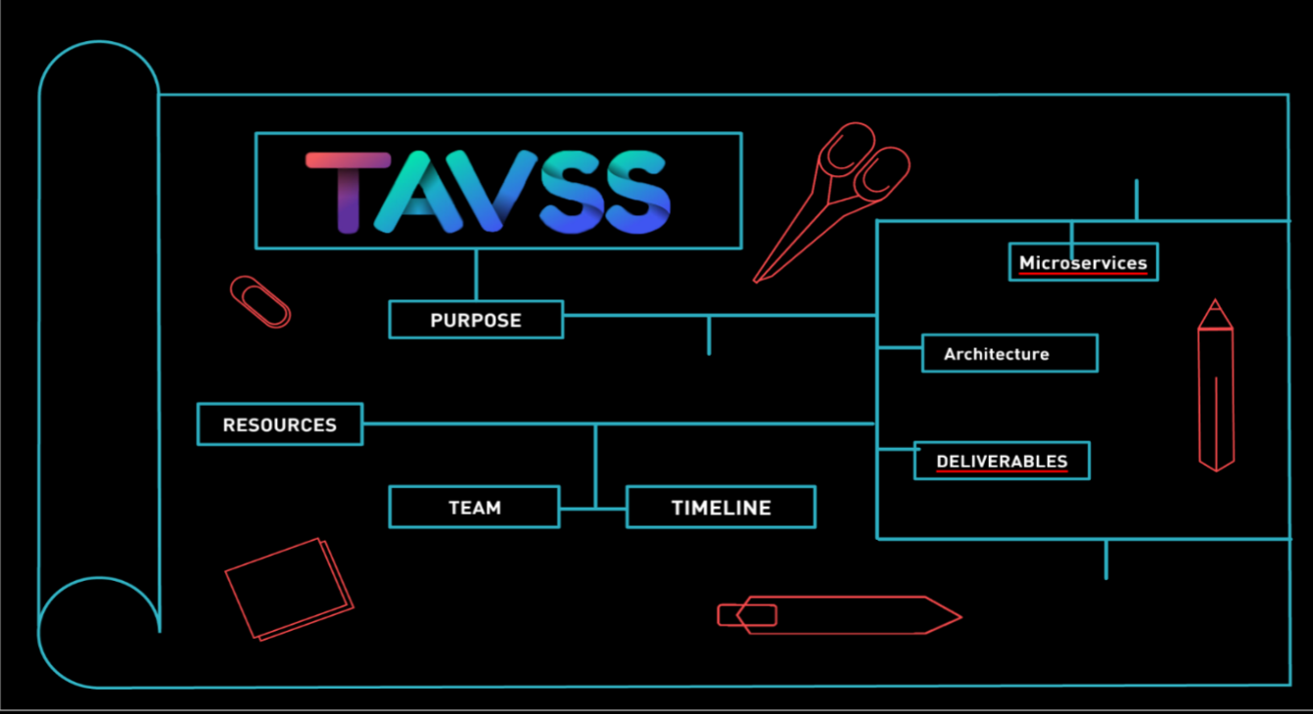 **A**ftertouching the tip of the E-learning Iceberg and Career Development concepts but when you are on the tip you can discover all the iceberg and make a solution to go to the next. The learning, career development and skills building are the obstacles on our lifecycle in our faculty. Many students suffer so we build our hypothesis on four steps that we discovered. the lifecycle starts with the student in all faculty years.

Figure 1.1 the map of work a presentation source for Prezi website <https://prezi.com/p/h3u0u9zheol/tavss/>

the life cycle form of learning by entertainment to interaction learning to skills building to develop the career of the student by supporting the integration of many system services that we tell every student loses these services in faculty, dividing them to internal and external services. Internal services like project, course, schedule, tasks, games and assignment management; external services like communities, teams, companies, training centers, market places and integration by the business using new methods of interaction like evaluation, chatting, blogging and cv development using standards as illustrated as Figure 1.1.

## 1.2 Objectives

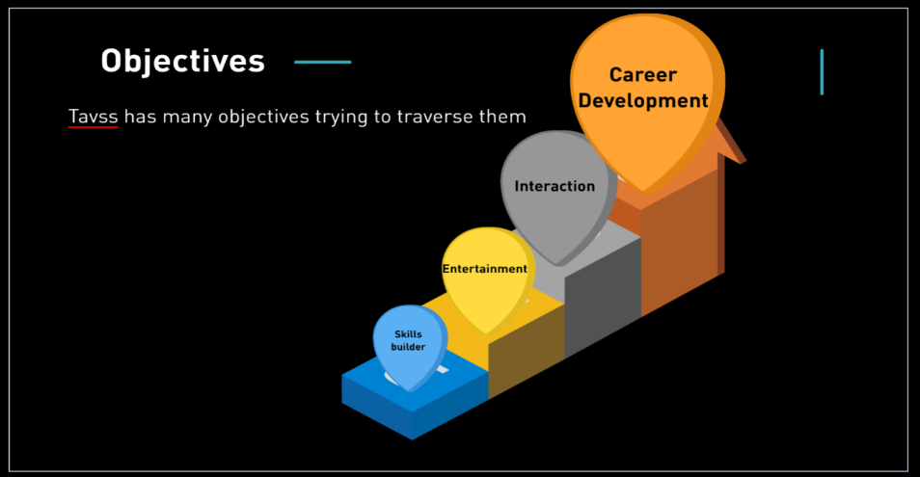

**T**he best goal we need to achieve is by creating channels between student, TAs, doctors and companies by supporting the entire services of communication and career development techniques by 4 steps of process integration as shown as Figure 1,2.

2 Figure 1.2 The steps of students on tavss website

* **Learning by entertainment:** is an internal integration process by use gaming, challenges, project challenging, scheduling times, assignments.
* **Interaction learning:**  Internal-External integration process by use development communities of faculty, training centers, companies, training courses, project challenging, gaming.
* **Skills Building:** Internal-External integration process by use soft skills building and development skills with communities and Skills Training centers like UCCD and ITI and other training models, with the acclaims of every students.
* **Career Development:** Internal-External Integration, every student here have cv , every cv built by the  previous 3 steps and the doctors, companies, training centers achieve the standards of cv making and career development technique.

If we need to Identify the problem, we need to define The **SWOT**

A SWOT analysis is a technique used to determine and define your Strengths, Weaknesses, Opportunities, and Threats – SWOT.

## 1.3 SWOT Analysis:

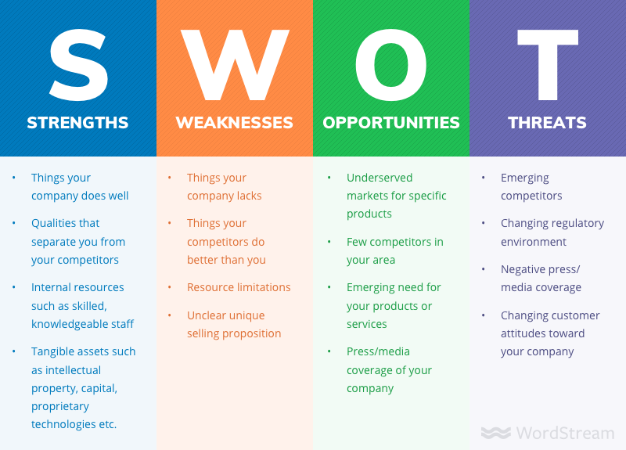SWOT analyses can be applied to an entire company or organization, or individual projects within a single department. Most commonly, SWOT analyses are used at the organizational level to determine how closely a business is aligned with its growth trajectories and success benchmarks, but they can also be used to ascertain how well a particular project – such as [an online advertising campaign](https://www.wordstream.com/blog/ws/2017/07/05/online-advertising-costs) – is performing according to initial projections as explained in figure 1.3.



Figure 1.4 the Main Swot Analysis components for decision making

3 Figure 1.3 have a long term plan from SWOT Analysis

Figure 1.5 Swot Analysis of CIS Faculty

Resources:

<https://www.wordstream.com/blog/ws/2017/12/20/swot-analysis>

## 1.4 Internal Vs External Services

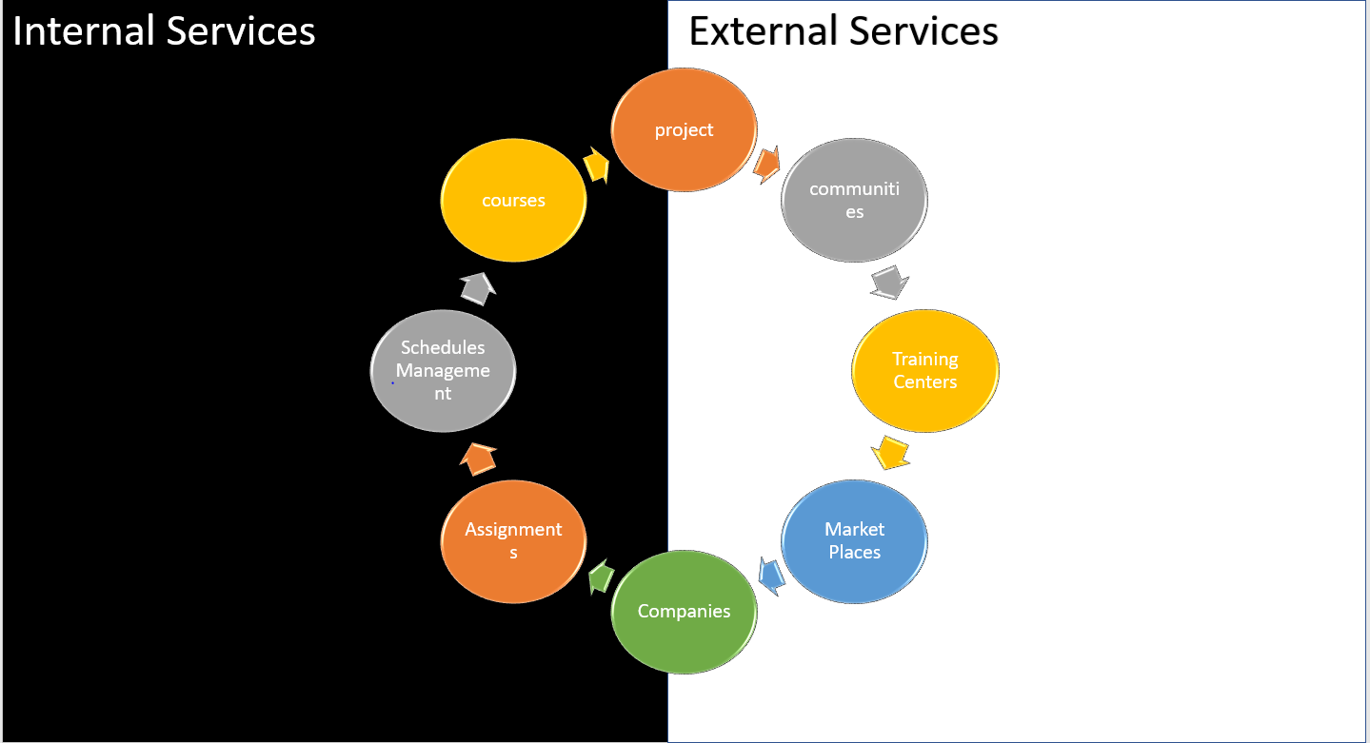

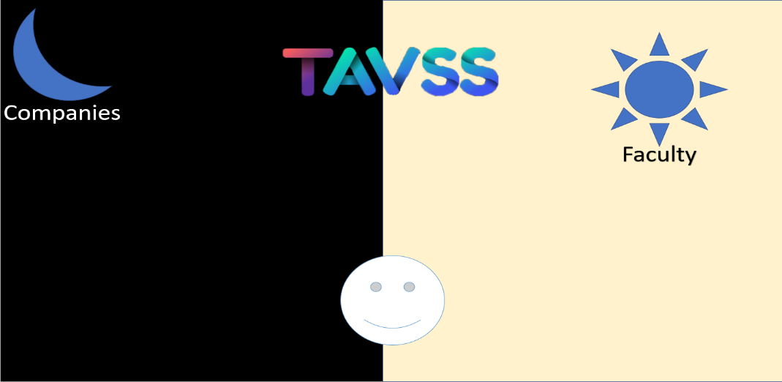Figure 1.6 Internal vs External services

Figure 1.7 how to combine the east of faculty and the west of company

Solving problem of students needs great effort to build a solution, and the swot analysis get the right action to predict, how to combine the light with dark, the dawn and night, but we can try to define the best solution for them as a system to serve them, we can define some services some of them are internal and the other are external:

**project service:** it is a service to manage the projects in the educational organization it provides download and upload projects, enable project evaluation, project documentation and interaction between different student’s project, between doctors, student and TAs

**communities:** provide a high communication with external communities to improve the performance and contribute in the organization in different ways even financial or worker etc.….

**Training centers:** provide a good relationship and powerful interaction with training centers for making the workers provide a higher performance and improve their skills

**market places:** Provide a high powerful communication technique to provide a high marketing for the organization so it will attract as much as we can of users

**courses:** it is a service to manage the courses in the educational organization it provides Module systems, module assignment, virtual classes and topic discussion

**schedule management:** it is a service to manage the schedule in the educational organization it provides Lecture alarm to notify students, doctors and TAs about lecture times and lecture director to notify them about the place and the lecture specific time

**Assignments:** it is a service to manage the assignments in the educational organization it provides prizes when success in specific assignment, provides a question and short quizzes which is even open or close and enable evaluation techniques for the assignments

**companies:** it is a service to manage the interaction between the system and any company that will use the system even for free or companies will buy it

## 1.5 Dimensions of Solution

Figure 1.8 The Dimensions of TAVSS

**We** need to redefine the new system to deal with the new Requirements with 3 dimensions:

**Business Layer:** To get the logic of building and combine multi-business architectures.

“The business logic layer is where you tackle the problems your program was created to solve. In the logic layer, classes decide what information they need in order to solve their assigned problems, request that information from the [accessor layer](https://www.sciencedirect.com/topics/computer-science/accessor-layer), manipulate that information as required, and return the ultimate results to the presentation layer for formatting.”[2]

**Architecture Pattern:** What is the best Pattern to recognize the requirements of multiple changing business?

refers to the fundamental structures of a [software system](https://en.wikipedia.org/wiki/Software_system) and the discipline of creating such structures and systems. Each structure comprises software elements, relations among them, and properties of both elements and relations. The *architecture* of a software system is a metaphor, analogous to the [architecture](https://en.wikipedia.org/wiki/Architecture) of a building.It functions as a blueprint for the system and the developing project, laying out the tasks not necessary to be executed by the design teams.[1]

**Student Requirements:** What is the best conceptual model can observe all these requirements?

Resources:

<https://www.sciencedirect.com/topics/computer-science/business-logic-layer>

## 1.6 A traditional model to solve problem



Figure 1.9 The Traditional Distributed System To solve the problem

This traditional Architecture that support student has a greet establishments, but it’s not sustainable for long term business, but this is the first architecture on our heads to support as illustrated in figure 1.7.

It’s not a Monolithic architecture, something more, something to higher up our faculty for business.

To Define this architecture, we have 2 phases a Modular one and a Structure one:

* **Modular Architecture:** The Applications are decomposed over the 3-tier architecture:
* **Data Access Layer+ Data Layer:** {SQL Server + NoSQL Mongo + some Middleware for integrations => Entity Framework}.
* **Business Logic Layer: {**Dotnet Core APIS+ djangorestframework API: to control the processing of transmission and the operations of business**}**
* **Presentation Layer: {**Web UIs+ Angular frontend, Android, IOS platforms for mobile user**}**
* **Structure:** Each app has its own design like:
* **Data Centric:** {MVC, MC} patterns
* **NoSQL vs SQL DB: {**Mongo vs SQL Server**}**
* **Http Restful Services: {**Get, Post, Put, Delete**}**
* **Asynchronous Messaging: {**RabbitMQ It will be explained in next Modules**,** SignalR: Chatting services for client server publish subscribe Design Pattern**}**

## 1.7 The Biggest deals of Architectures {Monolithic vs SOA VS MICROSERVICES}

Let’s now compare the Architectures of Designing a system and decide to take the best alternative of architectures:

1.7.1 Monolith**:**is an ancient word referring to a huge single block of stone. Though this term is used broadly today, the image remains the same across fields. In software engineering, a monolithic pattern refers to a single indivisible unit. The concept of monolithic software lies in different components of an application being combined into a single program on a single platform. Usually, a monolithic app consists of a database, client-side user interface, and server-side application. All the software’s parts are unified, and all its functions are managed in one place. Let’s look at the structure of the monolithic software in detail.

Figure 1.10 The simple Architecture of Monolithic app

1.7.2 A service-oriented architecture (SOA): is a software architecture style that refers to an application composed of discrete and loosely coupled software agents that perform a required function. SOA has two main roles: a service provider and a service consumer. Both of these roles can be played by a software agent. The concept of SOA lies in the following: an application can be designed and built in a way that its modules are integrated seamlessly and can be easily reused.

1.7.3 Microservice: is a type of service-oriented software architecture that focuses on building a series of autonomous components that make up an app. Unlike monolithic apps built as a single indivisible unit, microservice apps consist of multiple independent components that are glued together with APIs.

Figure 1.11 Simple Architecture Of SOA

****

Figure 1.12 Simple Microservice Architecture

**Microservices** are important simply because they add unique value in a way of simplification of complexity in systems. By breaking apart your system or application into many smaller parts, you show ways of reducing duplication, increasing cohesion and lowering your coupling between parts, thus making your overall system parts easier to understand, more scalable, and easier to change.

As organizations scale, their monolithic systems become [progressively complex and more difficult to manage](https://dzone.com/articles/microservices-in-practice-1). [6]This results in problems such as:

* **Lengthy downtime** **to undergo updates**: Since each service in a monolithic system is overly reliant with one another, updating one part of the system would require you to update the entire the system. Thus, requiring a significant amount of development time and resources.
* **High costs for expansions**: For scaling, monolithic systems usually require investment into more servers. Again, more cost is involved to acquire more servers.
* **Platform-wide Malfunctions**: This is perhaps the biggest pain point of a monolithic system. If one service within a monolithic system goes down, then this may initiate a chain reaction and could cause the entire system to go down.

### 1.7.4 To Go Macro, Go Micro

To put it bluntly, there’s a reason why some of the biggest players in the software industry to dumping the monolith in favor of the microservice. The former presents significant pains when it comes to scalability, deployment, and agile development — while the latter presents the antidote to those pains.

Investing in microservices may be costlier up front, but with speedier development processes, faster scalability, and the ability to more easily adapt to constantly fluctuating IoT-driven market, that investment makes a whole lot of sense.  [6]

Table 1.1 from dzone research as a comparison between SOA and Microservices



### 1.7.5 Pros and Cons of Architectures:

Table 1.2 The pros and cons of Many Distributed systems

|  |  |  |  |  |  |
| --- | --- | --- | --- | --- | --- |
|  |  | | Monolithic | SOA | Microservices |
| * Pros * Cons | | * 1)simple development and deployment * 2)fewer cross-cutting concerns * 3)Better performance | | * 1)Reusability of services * 2) Better Maintainability * 3) Higher reliability | * 1)Easy to develop, test, and deploy * 2) Increase Agility * 3)Ability to scale horizontally |
| * 1)code base come cumbersome over time * 2)Limited agility * 3)Difficult to adopt new technologies | | * 1)Complex management * 2) Extra overload * 3) High investment costs | * 1)Complexity: * 2) Security Concerns * 3)Different programming languages |

So After this short definition for each architecture if we want to decide which one of these strategies we will choose to implement TAVSS we will choose  microservice strategy which will make the system consists of independent components so any update or any attack or problems happens with any service will not affect the other services ,will choose the strategy that will focus on business priorities to improve TAVSS as an educational business ,Microservices are important simply because they add unique value in a way of simplification of complexity in the system. By breaking apart our system into many smaller parts, show ways of reducing duplication, increasing cohesion and lowering your coupling between parts, thus making your overall system parts easier to understand, and easier to change. One of the most important reasons for choosing this strategy because it increases agility which agility is the most powerful development strategies and finally scaling our system will be much easier.

Resources:

<https://rubygarage.org/blog/monolith-soa-microservices-serverless>

<https://dzone.com/articles/microservices-vs-soa-whats-the-difference>

## 1.8 The Plan of The Microservices Development

The best project management process for the microservices concept is the agile approach, Organizations as large as Amazon, Soundcloud and Netflix have already made successful transitions from monolithic architecture to microservices in recent years. But it’s not just the big guns; a Gartner [study](https://www.belatrixsf.com/blog/agile-development-is-ideally-suited-for-microservices/) from 2016 found that approximately 68 percent of organizations were either investigating or developing a microservice architecture.

### 1.8.1 How Microservices Improve Agile Development

Agile Development, which some refer to as ‘DevOps’, means having a number of small teams working on individual, smaller projects so that those projects are able to get a team’s undivided attention. This enables the individual projects to be completed quicker. Microservice architecture fits into this development model perfectly, as each small team can own and focus on one service. A recent study showed that projects managed under agile development tend to be [28 percent more successful](https://blog.capterra.com/agile-project-management-statistics-for-2018/) than traditional project management techniques.

By assigning a small team of 6-8 people to work on each microservice using the DevOps model, developers can, in theory at least, work more effectively and efficiently. But in order for DevOps to successfully develop and maintain a microservice architecture, strong project management is essential. Since multiple teams will be working on different elements, there is a possibility that some conflicts between the different teams will arise. For example, one team will feel that a certain task is not associated with their assigned microservice and could come back to management and say, “well, that’s not our problem”.

With a strong culture of collaboration and project management, DevOps can enable developers to work more effectively than they otherwise would with a monolithic system. This is reflected in the aforementioned Lightbend survey, with by 30 percent of respondents claiming that microservice architecture helped them increase development velocity for new releases.[6]

### 1.8.2 The plan decomposition



4 Figure 1.13 The decomposition mind map of project processes

### 1.8.3 Defining The Processes

Explaining every plan execution and delivery at the next tables:

Table 1.2 The planning phase Decomposition

|  |  |
| --- | --- |
| The Planning Phase | |
| SWOT consulting | Defining organization building blocks of {Strengths, Weaknesses, Opportunities, threats}. |
| Ideation | Design Thinking process to solve problems and making Automation |
| Problem Identification | Or problem statement to get the specified problem of an organization |
| Business Model Canvas | To follow strategic plan without losing the resources and control all our business |
| Alternative Analysis | Decision Making to get the action of the architecture to make or stop |
| Milestones | To Finnish the process |

|  |  |
| --- | --- |
| Conceptual Design of the models {DDD pattern} | |
| Bounded contexts | Breaking down the business to support many layer architecture for business to Microservices. |
| Modular system | Defining new technologies to support business |
| Microservice Architecture | Defining the real Architecture and how to connect Microservices |
| Devops | automates the processes between software development and IT teams, in order that they can build, test, and release software faster and more reliably. |
| Agile scrum framework | Subset of Agile a framework that helps teamwork together much like a rugby team |
| Microservice | arranges an application as a collection of loosely coupled services |

|  |  |
| --- | --- |
| Sprint1 {1/10:1/11 2019} | |
| breaking a [complex topic](https://en.wikipedia.org/wiki/Complexity) or substance into smaller parts in order to gain a better understanding of it | **Analysis (user story/Req class diagrams)** |
| Design API for identity service as software that intermediary allows identity service to talk to other services. | **Identity. API (SQL server + file system)** |
| Design API for course service as software that intermediary allows course service to talk to other services. | **Course.API**  **(Mongo+FSDB)** |
| Design API for project service as software that intermediary allows project service to talk to other services. | **Project.API**  **(Mongo + FSDB)** |
| Using sql server and mongo DB as a technique to develop data access layer | **SQL server +Mongo DB migration with data access layer** |
| process of verifying the identity of a person or device. + specifying access rights/privileges to resources, which is related to information security and computer security in general and to access control in particular | **Authentication**  **+ Authorization** |
| Brings a design-centric approach to user interface and user experience and offers a practical skill-based instruction -centered around a visual communication perspective with angular | **UI/UX +Angular** |
| automates the processes between software development and IT teams, in order that they can build, test, and release software faster and more reliably by (CI/CD +Testing +HCI). | **) Devops CI/CD +Testing +HCI** |
| Make it easier to create deploy and run applications by using containers to allow developer to backup an application with all parts it need | **Docker compose deployment** |
| allows describing the structure of APIs so that machines can read them | **{Swaggers + writing} documenting service** |

|  |  |
| --- | --- |
| Sprint3 {1/2:1/6 2020 } | |
| Increasing the project release and fix errors and problems | | Versioning up+ maintenance |
| Releasing the last versions of all APIs | | Finishing up all APIs |
| Making test to make sure if all services will satisfy its functions when integrate them together | | Integration test |
| Test if the entire system will satisfy it's functions and work well | | System testing |
| Releasing the last versions of the frontend | | Finishing up frontend |
| Releasing the last versions of Android mobile application | | Android finishing |
| Releasing the last versions of IOS mobile application | | IOS finishing |
| Starting automates the processes between software development and IT teams, in order that they can build, test, and release software faster and more reliably | | Devops starting operations |
| Writing the documentation for the system to document every step, tool and function in the system | | Documenting system |
| Releasing TAVSS to the users to use it | | Finishing the project |

|  |  |
| --- | --- |
| Sprint 2{1/11:1/2 2020} | |
| Start developing android and IOS mobile applications | Android +IOS starting |
| Design API for community’s service as software that intermediary allows course service to talk to other services | Communities. APIs |
| Design API for Acclaims service as software that intermediary allows course service to talk to other services | Acclaims. APIs |
| enables calling methods on connected clients from the server | SinalR HUB |
| open source message brokers. From [T-Mobile](https://www.youtube.com/watch?v=1qcTu2QUtrU) to [Runtastic](https://medium.com/@runtastic/messagebus-handling-dead-letters-in-rabbitmq-using-a-dead-letter-exchange-f070699b952b), RabbitMQ , is lightweight and easy to deploy on premises and in the cloud | Rabbit MQ service Bus |
| (CQRS)every [method](https://en.wikipedia.org/wiki/Method_(computer_science)) should either be a command that performs an action, or a query that returns data to the caller, but not both .+ (Ocelot BFF)Ocelot is an Open Source .NET Core based API Gateway especially made for microservices architecture that need unified points of entry into their system | CQRS+Ocelot BFF{Mediators+  Aggregators} |
| Deploy Make it easier to create deploy and run applications by using containers to allow developer to backup an application with all parts it need | Docker Deployment |
| automates the processes between software development and IT teams, in order that they can build, test, and release software faster and more reliably by (CI/CD +Testing +HCI) . | Devops(CI/CD+  Testing+HCI) |
| Writing the documentation for the system to document every step ,tool and function in the system | Documenting |
| brings a design-centric approach to user interface and user experience design, and offers practical, skill-based instruction centered around a visual communications perspective with angular | UI/UX Angular |

### 1.8.4 Scrum as Agile framework

First, defining the Software Agile Development approaches

The Agile methodologies outlined below share much of the same overarching philosophy, as well as many of the same characteristics and practices. From an implementation standpoint, however, each has its own unique mix of practices, terminology, and tactics.

#### **1.8.4.1 The most widely-used Agile methodologies include:**

* **Agile Scrum Methodology**
* **Lean Software Development**
* **Kanban**
* **Extreme Programming (XP)**
* **Crystal**
* **Dynamic Systems Development Method (DSDM)**
* **Feature Driven Development (FDD)**

In 1968, programmer Melvin Conway stated:

“organizations which design systems … are constrained to produce designs which are copies of the communication structures of these organizations.”

Basically, if you have three teams building a compiler, they’ll likely build a three-pass compiler, while if you only have two teams, you’ll get a two-pass compiler. Your architecture reflects your organizational structure, and if you want a certain technical architecture, you need to realign your organizational structure.

Since dubbed Conway’s Law, it rings especially true with microservices architecture today, which often aggravates communication problems.

Of course, if you take Whelan’s recommendation, while the team’s structure may change, “If a company wants to be successful in microservices, since microservices are small, they need to be handled by a single team, as they are in [Netflix](http://techblog.netflix.com/2015/02/a-microscope-on-microservices.html) and [Amazon](http://www.slideshare.net/nathariel/scaling-microservices-architecture-on-aws). Then that team needs to be responsible for concept to cash.” If the entire team is responsible from start to finish, this would certainly diminish the problem of ownership.

“Microservices will drive team boundaries in a different way because it’s going to be hard to have three teams working on the microservices. If you are looking at continuous delivery, you need a single team, and then Conway’s Law kicks in and your team has to mirror your product-slash-microstructure.” Of course Whelan admits this is impossible to coordinate across large-scale organizations.

#### 1.8.4.2 Be Wary of Scrum Ignoring Analysis and Design

Scrum can actually do damage to your technical assets. “There has been a steady decline in technical focus with agile transformations. As a really technical agile coach, that disturbs me because I think that organizations need a multifaceted approach to agility. Scrum doesn’t provide any guidance on technical practice by design”.

“Many organizations that adopt scrum get really good at building technical debt quickly.” It’s essential to remember that while microservices is all about scaling independently, you can’t lose track of broader objectives and how everything connects.

Whelan warns that the popular scrum framework comes with intentional holes that, if not well planned for, leave holes in your microservices architecture.

“If you had a traditional waterfall, if you used to do analysis and design and take care of the technical details, you need to be doing it in another way, but scrum doesn’t allow” for that. “If you aren’t replacing that with anything else, you’re really just having feature after feature after feature,” Whelan said, “and, after a while, your technical core will be a huge waste and you’ll just have to rewrite and rewrite and rewrite.”

His team uses a product owner with microservices, but otherwise follows kanban with weekly ceremonies.



Figure 1.14 The Scrum Product framework



Figure 1.15 The Releasing timeline

### 1.8.5 The 4 Agile Sprints:



# CHapter 2: Architecture Building

## 2.1 Microservice Design Patterns

Because of the complexity and the large scale of Microservices architecture we need to define how can solve the complexity and using many patterns that can help the project to be more valuable, so if there a need to get more accurate architecture, must follow greet patterns:

5 Figure 2.1 The Design Pattern image

### 2.1.1 Domain Driven Design

Domain-Driven Design is a set of tools or patterns that are used in designing and implementing the software that delivers high value, both strategically and tactically. By using DDD strategic development tools, you and your team will be able to create the competitively best software design choices and integration decisions for your business.

Figure 2.2 The Domain Driven Design

In order to design a useful software, which accurately models the unique operations of the business, you can use DDD tactical development tools to assist you and your team.  
DDD is the most effective software design and implementation needed to succeed in today’s competitive business landscape. Complicated? Not Necessarily. However, it does involve a set of advanced techniques to be used on complex software projects. Domain-Driven Design will bring domain experts and software developers together to create a software solution that reflects the mental model of business experts. It is essential to have the same understanding of the business and provide a solution to help business processes.

Therefore, the DDD method will need to invest in resources.   
Within our team, we have domain experts using the DDD. This way, the team will not only deliver the application but the true business value application. [2]

Domain-driven design (DDD), a software development technique first proposed by [Eric Evans](http://domainlanguage.com/ddd/), includes strategic, philosophical, tactical, and technical elements and is related to many specific practices. I've written about [why you need DDD (even though you think you don't)](http://techbeacon.com/why-you-need-domain-driven-design).

#### DDD strategy and philosophy

You probably know that DDD has strategic value; that’s why so many companies with extremely complex domains rely on it to produce software that can rapidly evolve with the business. But did you know that DDD also has a philosophical theme? You might have heard the term “ubiquitous language,” which is a mouthful when you’re speaking about it, but it’s a shorthand way of emphasizing the fundamental principle of DDD: Use domain terminology everywhere; make it ubiquitous. When practicing DDD, this basic philosophy of the primacy of domain terminology can be distributed across three guiding principles:

1. Capture the domain model, in domain terms, through interactions with domain experts.

In other words, talk to the people in the businesses where you are solving problems and understand them from their point of view first and foremost. This is how you form the [ubiquitous language](http://martinfowler.com/bliki/UbiquitousLanguage.html) of the domain and set the foundation for harmonious models.

1. Embed the domain terminology in the code.

This means naming things the way the domain expert would name them, including classes, methods, commands, and especially domain events. This is how you reflect the domain model in the code.

1. Protect the domain knowledge from corruption by other domains, technical subdomains, etc.

If you find that your code is talking about two different things—e.g., the domain solution and the technical implementation—separate those components to keep the subdomains apart. This strategy tends to result in classes with single responsibilities and a terse, focused vocabulary. Put "translators" at the [boundaries](http://techbeacon.com/domain-driven-design-boundaries-leaking) between subdomains to keep them from depending on each other’s structures unnecessarily, and also to prevent blurring of the meaning of domain terms.

These three principles guide and inform DDD. Knowing and using them provides benefits, even without the rest of the DDD practices and patterns. Let’s look at how we might reap some benefits from just using this information in our software development projects.

### 2.1.2 Communication in a microservice architectur

In a monolithic application running on a single process, components invoke one another using language-level method or function calls. These can be strongly coupled if you’re creating objects with code (for example, new ClassName()), or can be invoked in a decoupled way if you’re using Dependency Injection by referencing abstractions rather than concrete object instances. Either way, the objects are running within the same process. The biggest challenge when changing from a monolithic application to a microservices-based application lies in changing the communication mechanism. A direct conversion from in-process method calls into RPC calls to services will cause a chatty and not efficient communication that won’t perform well in distributed environments. The challenges of designing distributed system properly are well enough known that there’s even a canon known as the Fallacies of distributed computing that lists assumptions that developers often make when moving from monolithic to distributed designs.

There isn’t one solution, but several. One solution involves isolating the business microservices as much as possible. You then use asynchronous communication between the internal microservices and replace fine-grained communication that’s typical in intra-process communication between objects with coarser-grained communication. You can do this by grouping calls, and by returning data that aggregates the results of multiple internal calls, to the client.

**A microservices-based application** is a distributed system running on multiple processes or services, usually even across multiple servers or hosts. Each service instance is typically a process. Therefore, services must interact using an inter-process communication protocol such as **HTTP, AMQP**, or a binary protocol like TCP, depending on the nature of each service.

The microservice community promotes the philosophy of “smart endpoints and dumb pipes” This slogan encourages a design that’s as decoupled as possible between microservices, and as cohesive as possible within a single microservice. As explained earlier, each microservice owns its own data and its own domain logic. But the microservices composing an end-to-end application are usually simply choreographed by using REST communications rather than complex protocols such as WS-\* and flexible event-driven communications instead of centralized business-process-orchestrators.

The two commonly used protocols are HTTP request/response with resource APIs (when querying most of all), and lightweight asynchronous messaging when communicating updates across multiple microservices.

#### 2.1.2.1 Communication types

Client and services can communicate through many different types of communication, each one targeting a different scenario and goals. Initially, those types of communications can be classified in two axes.

##### 2.1.2.1.1 The first axis defines if the protocol is synchronous or asynchronous:

* + **Synchronous protocol.** HTTP is a synchronous protocol. The client sends a request and waits for a response from the service. That’s independent of the client code execution that could be synchronous (thread is blocked) or asynchronous (thread isn’t blocked, and the response will reach a callback eventually). The important point here is that the protocol (HTTP/HTTPS) is synchronous and the client code can only continue its task when it receives the HTTP server response. [4]



Figure 2.5 The Request Response synchronous transmission

* + **Asynchronous protocol**. Other protocols like AMQP (a protocol supported by many operating systems and cloud environments) use asynchronous messages. The client code or message sender usually doesn’t wait for a response. It just sends the message as when sending a message to a RabbitMQ queue or any other message broker. [4]



Figure 2.6 The Magic about Asynchronous transmission is to develop multi-programming language application

##### 2.1.2.1.2 The second axis defines if the communication has a single receiver or multiple receivers:

* + **Single receiver**. Each request must be processed by exactly one receiver or service. An example of this communication is the Command pattern.
  + **Multiple receivers**. Each request can be processed by zero to multiple receivers. This type of communication must be asynchronous. An example is the publish/subscribe mechanism used in patterns like Event-driven architecture. This is based on an event-bus interface or message broker when propagating data updates between multiple microservices through events; it’s usually implemented through a service bus or similar artifact like Azure Service Bus by using topics and subscriptions.

A microservice-based application will often use a combination of these communication styles. The most common type is single-receiver communication with a synchronous protocol like HTTP/HTTPS when invoking a regular Web API HTTP service. Microservices also typically use messaging protocols for asynchronous communication between microservices.

These axes are good to know so you have clarity on the possible communication mechanisms, but they’re not the important concerns when building microservices. Neither the asynchronous nature of client thread execution nor the asynchronous nature of the selected protocol is the important points when integrating microservices.

What is important is being able to integrate your microservices asynchronously while maintaining the independence of microservices.

### 2.1.2.2 Asynchronous microservice integration enforces microservice’s autonomy

As mentioned, the important point when building a microservices-based application is the way you integrate your microservices. Ideally, you should try to minimize the communication between the internal microservices. The fewer communications between microservices, the better. But in many cases, you’ll have to somehow integrate the microservices. When you need to do that, the critical rule here is that the communication between the microservices should be asynchronous. That doesn’t mean that you must use a specific protocol (for example, asynchronous messaging versus synchronous HTTP). It just means that the communication between microservices should be done only by propagating data asynchronously but try not to depend on other internal microservices as part of the initial service’s HTTP request/response operation. [4]

If possible, never depend on synchronous communication (request/response) between multiple microservices, not even for queries. The goal of each microservice is to be autonomous and available to the client consumer, even if the other services that are part of the end-to-end application are down or unhealthy. If you think you need to make a call from one microservice to other microservices (like performing an HTTP request for a data query) to be able to provide a response to a client application, you have an architecture that won’t be resilient when some microservices fail as illustrated In figure 2.7.

Moreover, having HTTP dependencies between microservices, like when creating long request/response cycles with HTTP request chains, as shown in the first part of the Figure 2.7, not only makes your microservices not autonomous but also their performance is impacted as soon as one of the services in that chain isn’t performing well.

The more you add synchronous dependencies between microservices, such as query requests, the worse the overall response time gets for the client apps.



Figure 2.7 The 3 ways of Microservices communication

If your microservice needs to raise an additional action in another microservice, if possible, do not perform that action synchronously and as part of the original microservice request and reply operation. Instead, do it asynchronously (using asynchronous messaging or integration events, queues, etc.). But, as much as possible, do not invoke the action synchronously as part of the original synchronous request and reply operation.

And finally (and this is where most of the issues arise when building microservices), if your initial microservice needs data that’s originally owned by other microservices, do not rely on making synchronous requests for that data. Instead, replicate or propagate that data (only the attributes you need) into the initial service’s database by using eventual consistency (typically by using integration events, as explained in upcoming sections).

As noted earlier in the section Identifying domain-model boundaries for each microservice, duplicating some data across several microservices isn’t an incorrect design—on the contrary, when doing that you can translate the data into the specific language or terms of that additional domain or Bounded Context. For instance, in the Tavss application you have a microservice named identity.api that’s in charge of most of the user’s data with an entity named User. However, when you need to store data about the user within the Project microservice, you store it as a different entity named Acclaim. The Acclaim entity shares the same identity with the original User entity, but it might have only the few attributes needed by the Acclaim domain, and not the whole user profile.

You might use any protocol to communicate and propagate data asynchronously across microservices in order to have eventual consistency. As mentioned, you could use integration events using an event bus or message broker or you could even use HTTP by polling the other services instead. It doesn’t matter. The important rule is to not create synchronous dependencies between your microservices.

The following sections explain the multiple communication styles you can consider using in a microservice-based application.

## 2.2 What is Docker?

### 2.2.1 Introduction to Docker

Docker is an open-source project for automating the deployment of applications as portable, selfsufficient containers that can run on the cloud or on-premises. Docker is also a company that promotes and evolves this technology, working in collaboration with cloud, Linux, and Windows vendors, including Microsoft.[3]

Figure 2.3 Docker Logo

Docker image containers can run natively on Linux and Windows. However, Windows images can run only on Windows hosts and Linux images can run on Linux hosts and Windows hosts (using a Hyper-V Linux VM, so far), where host means a server or a VM. Developers can use development environments on Windows, Linux, or macOS as shown as figure 2.4

Figure 2.4. Docker deploys containers at all layers of the hybrid cloud

On the development computer, the developer runs a Docker host where Docker images are deployed, including the app and its dependencies. Developers who work on Linux or on the Mac, use a Docker host that’s Linux based, and they can only create images for Linux containers. (Developers working on the Mac can edit code or run the Docker command-line interface (CLI) from macOS, but as of this writing, containers don’t run directly on macOS.)

Developers who work on Windows can create images for either Linux or Windows Containers. To host containers in development environments and provide additional developer tools, Docker ships Docker Community Edition (CE) for Windows or for macOS.

These products install the necessary VM (the Docker host) to host the containers. [4]

Docker also makes available Docker Enterprise Edition (EE), which is designed for enterprise development and is used by IT teams who build, ship, and run large business-critical applications in production. To run Windows Containers, there are two types of runtimes:

* + **Windows Server Containers** provide application isolation through process and namespace isolation technology. A Windows Server Container shares a kernel with the container host and with all containers running on the host. 3 Introduction to containers and Docker.
  + **Hyper-V Containers** expand on the isolation provided by Windows Server Containers by running each container in a highly optimized virtual machine. In this configuration, the kernel of the container host isn’t shared with the Hyper-V Containers, providing better isolation. The images for these containers are created and work just the same way. The difference is in how the container is created from the image—running a Hyper-V Container requires an extra parameter. For details, see Hyper-V Containers.

### 2.2.2 why Docker

### 2.2.3 Docker terminology

This section lists terms and definitions you should be familiar with before getting deeper into Docker. For further definitions, see the extensive glossary provided by Docker.

* **Container image**: A package with all the dependencies and information needed to create a container. An image includes all the dependencies (such as frameworks) plus deployment and execution configuration to be used by a container runtime. Usually, an image derives from multiple base images that are layers stacked on top of each other to form the container’s filesystem. An image is immutable once it has been created.
* **Dockerfile**: A text file that contains instructions for how to build a Docker image. It’s like a batch script, the first line states the base image to begin with and then follow the instructions to install required programs, copy files and so on, until you get the working environment you need.
* **Build**: The action of building a container image based on the information and context provided by its Dockerfile, plus additional files in the folder where the image is built. You can build images with the Docker docker build command.
* **Container**: An instance of a Docker image. A container represents the execution of a single application, process, or service. It consists of the contents of a Docker image, an execution environment, and a standard set of instructions. When scaling a service, you create multiple instances of a container from the same image. Or a batch job can create multiple containers from the same image, passing different parameters to each instance.
* **Volumes**: Offer a writable filesystem that the container can use. Since images are read-only but most programs need to write to the filesystem, volumes add a writable layer, on top of the container image, so the programs have access to a writable filesystem. The program doesn’t know it is accessing a layered filesystem, it is just the filesystem as usual. Volumes live in the host system and are managed by Docker.
* **Tag**: A mark or label you can apply to images so that different images or versions of the same image (depending on the version number or the target environment) can be identified.
* **Multi-stage Build**: Is a feature, since Docker 17.05 or higher, that helps to reduce the size of the final images. In a few sentences, with multi-stage build you can use, for example, a large base image, containing the SDK, for compiling and publishing the application and then using the publishing folder with a small runtime-only base image, to produce a much smaller final image
* **Repository** (repo): A collection of related Docker images, labeled with a tag that indicates the image version. Some repos contain multiple variants of a specific image, such as an image containing SDKs (heavier), an image containing only runtimes (lighter), etc. Those variants can be marked with tags. A single repo can contain platform variants, such as a Linux image and a Windows image.
* **Registry:** A service that provides access to repositories. The default registry for most public images is Docker Hub (owned by Docker as an organization). A registry usually contains repositories from multiple teams. Companies often have private registries to store and manage images they’ve created. Azure Container Registry is another example.
* **Multi-arch image**: For multi-architecture, is a feature that simplifies the selection of the appropriate image, according to the platform where Docker is running, e.g. when a Dockerfile requests a base image FROM mcr.microsoft.com/dotnet/core/sdk:2.2 from the registry it actually gets 2.2-sdknanoserver-1709, 2.2-sdk-nanoserver-1803, 2.2-sdk-nanoserver-1809 or 2.2-sdk-stretch, depending on the operating system and version where Docker is running.
* **Docker Hub:** A public registry to upload images and work with them. Docker Hub provides Docker image hosting, public or private registries, build triggers and web hooks, and integration with GitHub and Bitbucket.
* **Azure Container Registry:** A public resource for working with Docker images and its components in Azure. This provides a registry that is close to your deployments in Azure and that gives you control over access, making it possible to use your Azure Active Directory groups and permissions.
* **Docker Trusted Registry (DTR):** A Docker registry service (from Docker) that can be installed onpremises so it lives within the organization’s datacenter and network. It is convenient for private images that should be managed within the enterprise. Docker Trusted Registry is included as part of the Docker Datacenter product. For more information, see Docker Trusted Registry (DTR).
* **Docker Community Edition (CE):** Development tools for Windows and macOS for building, running, and testing containers locally. Docker CE for Windows provides development environments for both Linux and Windows Containers. The Linux Docker host on Windows is based on a Hyper-V virtual machine. The host for Windows Containers is directly based on Windows. Docker CE for Mac is based on the Apple Hypervisor framework and the xhyve hypervisor, which provides a Linux Docker host virtual machine on Mac OS X. Docker CE for Windows and for Mac replaces Docker Toolbox, which was based on Oracle VirtualBox.
* **Docker Enterprise Edition (EE):** An enterprise-scale version of Docker tools for Linux and Windows development.
* **Compose:** A command-line tool and YAML file format with metadata for defining and running multi container applications. You define a single application based on multiple images with one or more .yml files that can override values depending on the environment. After you have created the definitions, you can deploy the whole multi-container application with a single command (dockercompose up) that creates a container per image on the Docker host.
* **Cluster:** A collection of Docker hosts exposed as if it were a single virtual Docker host, so that the application can scale to multiple instances of the services spread across multiple hosts within the cluster. Docker clusters can be created with Kubernetes, Azure Service Fabric, Docker Swarm and Mesosphere DC/OS.
* **Orchestrator**: A tool that simplifies management of clusters and Docker hosts. Orchestrators enable you to manage their images, containers, and hosts through a command line interface (CLI) or a graphical UI. You can manage container networking, configurations, load balancing, service discovery, high availability, Docker host configuration, and more. An orchestrator is responsible for running, distributing, scaling, and healing workloads across a collection of nodes. Typically, orchestrator products are the same products that provide cluster infrastructure, like Kubernetes and Azure Service Fabric, among other offerings in the market

### 2.2.4 Docker Orchestration

### 2.2.5 Clustering

## 2.3 Building Blocks

## 2.4 Domain Driven Design Pattern

## 2.5 Bounded Contexts

## 2.6 Conceptual Design Model

## 2.7 Architecture Building



## 2.8 Summary

# CHAPTER 3: Microservices Design

## 3.1 The Conceptual Design





## 3.2 Identity MicroServices

Identity micro service is one of the most important micro services in TAVSS. Identity will provide lots of features that it is responsible for determining who is the current user in the system , who is the suitable and the permissioned user to every micro service ex: is he a doctor or student ? ,responsible to notify the admin of the system who is the current user login to the system ?? who tried to log the service?? The result of this service allow the Admin to grant or revoke the user access depending on his permissions .It is a very important service for protecting against hacking and it can find and detect if the user was an original user or hacker .

## 3.3 Project MicroServices

Students always need to make project ,need to manage there projects ,need to be followed up by their doctors and TAs and after finishing the project evaluating and ranking will be the next needed step and marketing is the most important for a powerful startup for a project and contact with the external companies , so, One of the most important micro services in TAVSS is Project micro service , Project micro service will provide lots of features that users as students, teams, doctors and teacher assistants can attain and acquire these features and interact with them.

Project micro service provide to the user Download and Upload features for students or teams to download their projects to modify them or to share it and upload their projects on TAVSS so TAs ,Doctors or other teams and students can perusal them. After uploading the project Another feature in project micro service will be important which is a documentation feature which is allow students to document their projects and explain all the project sides and how it implemented so, it can be more clear and understandable to every one . After uploading and documenting the project doctors and TAs will Evaluate the project which is another feature in project service that after evaluation project ranking will be applied depending on ranking there will be an acclaims which is another micro service ,will be explained in another section .when applying these three features it will be inevitable to have interaction which is another feature in project micro service ,this interaction will be between doctors, TAs and students.

### 3.3.1 project microservice Use Case

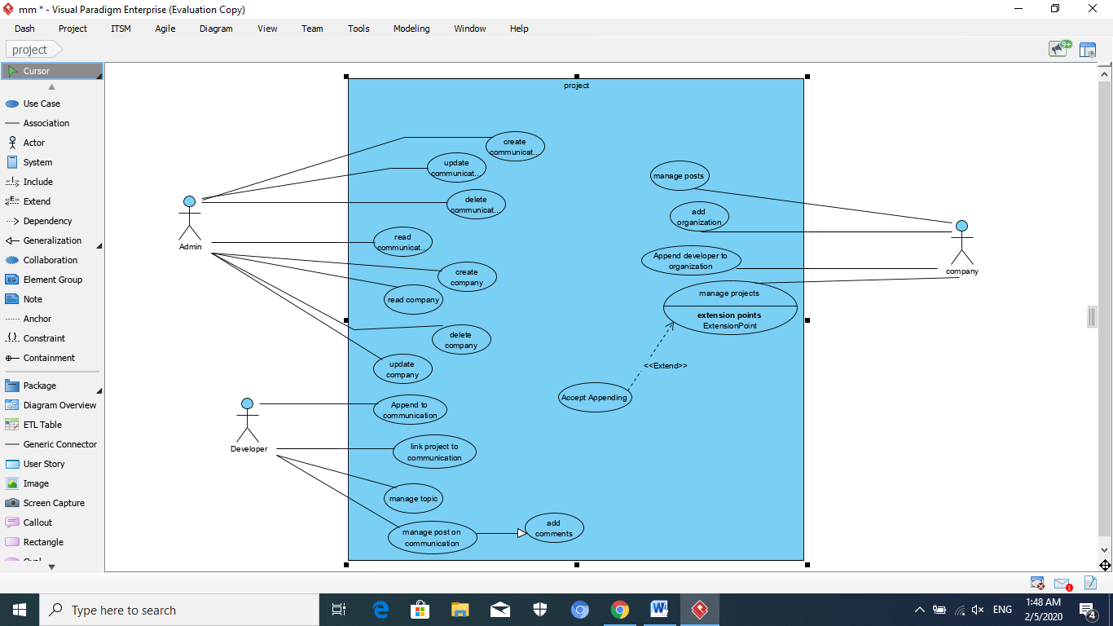

Figure 3.3.1project micro service use case diagram

Project micro service use case there will have three actors: Admin to manage the authentication and authorization in project service with doctors, students(developers) and TAs , Company actor will have a very important role because they will be the startup for every project and the way to have a marketing for the project , Developer actor is important actor because he will work on the project .each one of these three actors will have a use cases (functions) explains his mission in the system.

developers as students(teams) or TAs and companies need to share experience or share their projects with companies to market for them or to make a startup for the project Admin will create a communication between them that will be by allow developers to make a communication with companies so TAs will follow up team progress in the project by communication between the developers , instruct teams about their projects and evaluate the final project or the project prototypes all of this will be Supervised by the Admin . sometimes user needs to update communication by make changes in the communication between developers and companies, changing the company for the developers , changing the peers of the communication, for example if the TAs for the team has been changed so the peers of the communication will need to have a changes by the admin, changing the TAs instructions for the team adding new instructions or changing the evaluation of the project team need to be supervised by the admin. Also admin will have the permission to give the availability for reading or not reading any communication between any two peers . But if ending the communication between them even company or a developer needed to be done so the admin will be responsible for deleting this communication after taking the agree from them . one of the admin functions is creating a company which allows the project to be supported by external company admin also can allow changing the company that will be supporter for the project or allow any developer to read about the supporter company of the project or deleting this company so it will not be a supporter for the project.

Developer needs append to a communication with a company to share its experience or to share his visions with the company as a team or individual. When user accept the appending he can link his project to the communication between him and the company. Also developer will be responsible for managing kinds of topics that will be shared with a company and filtering what he could share with him and what he could not. He will managing the posts on communication by generate posts on the communication channel between them. The developer and the company can add comments in the posts to have a discussion about the post.

Every company need to manage the kind of posts and the content of these posts ,need to filtering the kind of the organization will be added to the company and managing the project that will be shared from developers by send an appending request for the developers who the company need to contact with them in the first of all so use case diagram contained the company actor who will solve all these problems.

## 3.4 Course MicroServices

Another important micro services in TAVSS is course micro service , course micro service will provide lots of features that users as students ,teams ,doctors and teacher assistants can attain and acquire these features and interact with them.

Doctors always need to insert and assign their courses in the system also students always need to be assigned in their courses and know their doctors and TAs in every course so, they will have a module system feature in course micro service in TAVSS which will solve this problem .After the doctor assigning his course and lectures he can give his student an assignment using Assignment module feature. Another advanced way for doctors for teaching their students which is Virtual classes which allow doctors to make online courses on TAVSS which will be easier more effective and will be a good solution for students who can not go to a university. Finally if students need a discussion between doctors , course micro service will allow discussion between doctors and their student about the course lectures .

### 3.4.1 course microservice Use Case

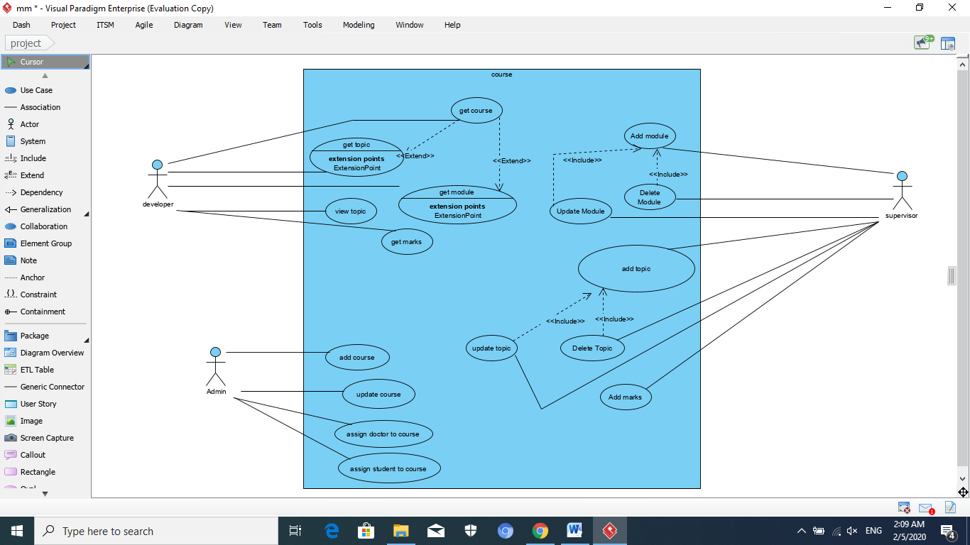

Figure 3.4.1course micro service use case diagram

if the doctor or instructor want to assign a course on TAVSS he must take a permission to make sure that the course not teaching by another doctor so, Course micro service will have Admin actor who will have a permission that allow him to add courses to TAVSS , if a doctor wants to update a course a doctor will insert his updates but the admin will be responsible for applying these updates , also admin will have a permission to assign the suitable doctor to his suitable course depends on the college instructions ,admin also will have all permissions that allow him to assign student in his suitable course depending on doctor instructions and finally getting all the courses on TAVSS and getting their topics and modules .

every student need to get a course and as a result he can get the topic which is the general titles in the course and modules which is the content of the of the course ,view topic and get marks . Developer actor will have a permission for getting all the courses on TAVSS and getting their topics and modules also he has a permission to get just a view of the topic of the course not the original version of the topic , finally, he has a permission to get his marks in the course .

Supervisor actor will be a more specific for the courses than admin he has a permission to add a module in a course which is the content of the course so he can update or delete this module also he can add topic to a course which is the general titles in the course and delete or update these titles and he will add the student marks in every course in the system.

### 3.4.2 course class Diagram



Figure 3.4.2course micro service class diagram

Every user in any system need to have an information, so in TAVSS every user doctor or student will have an information. Class diagram will contain Iuser interface parent class containing all information can user have even he was a doctor or student (child classes). As we know every student and doctor belong to a specific department so Department enumeration class will contain a static values for the departments every user even doctor or student need to have one value of Department class. Also doctor will teach a course and student will learn that course so course class important will be very important to contain information for every course and who is the doctors will teach and students will learn that course. Every course contains topics and modules which will be in module class and topic classes , these two classes will contain all information needed for each one of them and which course they belong to.

### 3.4.3 Course class Diagram



Figure 3.4.2course micro service class diagram

In course service using MVC modeling will be very perfect to improve the service performance ,first of all Modeling . Every doctor need a part in database to save his information ,so as students need a database for saving information and courses need also database for saving any information about courses in the system , as a result student service class , doctor service class and doctor service class was important to be excited

Second doctor , students need a an interface to connect the user to the database of the system in the system so as a result Istudent service and Idoctor service class important which will be like a view in MVC . courses need an interface to connect course database with the users in a view so, Icourse service class which will be like the view in MVC.

Finally doctor and students need to perform functions and interact with courses in the system so , course controller will be responsible for handling ,controlling and performing all the functions in the system , to assign results and changes in the model

## 3.5 Acclaim MicroServices

Another important micro services in TAVSS is Acclaim Microservices , Acclaim Microservices will provide lots of features that users as students ,teams ,doctors and teacher assistants can attain and acquire these features and interact with them .Acclaim Microservices will give each student a specific rank on TAVSS depending on contributions, winning a competition with his project, as a result of this rank he can take number of xp points,also he can take Badges after finishing model in every course ,finally he can get a Certificates after finishing the entire course.

### 3.5.1 Acclaim MicroServicesSequence Diagram

Sequence diagrams in UML show how objects interact with each other and the order those interactions occur. It’s important to note that they show the interactions for a particular scenario. The processes are represented vertically and interactions are shown as arrows



Figure 3.5.1Acclaim micro service sequence diagram

Acclaim sequence diagram two important actors will interact in the system: Developer and Admin.

Sometimes user need to get an acclaim so he send a message per acclaim API to ask for an acclaim, depending on acclaim type the system will send a message to the right sub system either it was project, course or assignment acclaim and waiting for a response from the system.

Also if developers need to get an acclaim badge so, they send a message per acclaim API to ask for an acclaim badge and waiting for system results .

When developer request an acclaim he need a granting or revoking from the system which is the Admin role to interact with acclaim DB in the system, also deleting an acclaim from the system is Admin role by deleting from acclaim DB . Finally if developer needs to show all acclaims he has got he can sending a request to the acclaims api which will search in acclaimDB for all acclaims for the requested developer.

“All of these functions can be applied by interacting through Acclaim API”.

## 3.6 Communities MicroServices

Communities micro service will be responsible for any communication even it was broadcast, multi cast ,peer to peer, unicast between doctors, students, developers, TAs, companies or organization there will be a strong connection between the connector , high security and have a good manage .This communication can be done even by chatting ,posts and comments on these posts, surveys and reacting by emojies.

### 3.6.1 Communities usecase Diagram



Figure 3.6.2communities micro service use case diagram

communities micro service use case there will have three actors: Admin to manage the authentication and authorization in community service with doctors, students(developers) and TAs , Company actor will have a very important role because they will be the startup for every project and the way to have a marketing for the project , Developer actor is important actor because he will work on the project .each one of these three actors will have a use cases (functions) explains his mission in the system.

developers as students(teams) or TAs and companies need to share experience or share their projects with companies to market for them or to make a startup for the project Admin will create a communication between them that will be by allow developers to make a communication with companies so also TAs will follow up team progress in the project by communication between the developers , instruct teams about their projects and evaluate the final project or the project prototypes all of this will be Supervised by the Admin . sometimes user needs to update communication by make changes in the communication between developers and companies, changing the company for the developers , changing the peers of the communication, for example if the TAs for the team has been changed so the peers of the communication will need to have a changes by the admin, changing the TAs instructions for the team adding new instructions or changing the evaluation of the project team need to be supervised by the admin. Also, admin will have the permission to give the availability for reading or not reading any communication between any two peers. But if ending the communication between them even company or a developer needed to be done so the admin will be responsible for deleting this communication after taking the agree from them . one of the admin functions is creating a company which allows the project to be supported by external company admin also can allow changing the company that will be supporter for the project or allow any developer to read about the supporter company of the project or deleting this company so it will not be a supporter for the project.

Developer needs append to a communication with a company to share its experience or to share his visions with the company as a team or individual. When user accept the appending he can link his project to the communication between him and the company. Also developer will be responsible for managing kinds of topics that will be shared with a company and filtering what he could share with him and what he could not. He will managing the posts on communication by generate posts on the communication channel between them. The developer and the company can add comments in the posts to have a discussion about the post.

Every company need to manage the kind of posts and the content of these posts ,need to filtering the kind of the organization will be added to the company and managing the project that will be shared from developers by send an appending request for the developers who the company need to contact with them in the first of all so use case diagram contained the company actor who will solve all these problems.

### 3.6.2 Communities SequenceDiagram



Figure 3.6.1communities micro service sequence diagram

Having an idea about the operations available for each user and the relations between them in usecase diagram ,we are going to dig deeper and see how they are done, communities sequence diagram has three important actors will interact in the system: Developer, company and Admin.

If any community needed to be establish it must be initiated by Admin by assigning this community in the DB of the system, developer and company who will responsible for assigning organizations to that community by inserting organization to the community in the DB of the system, also both of them can generate posts in the same way , after post generating this post need to be broadcasted to the developers , finally if the company need show all the project it will send a request to the DB to return all projects to the company.

“All of these functions can be applied by interacting through community API”.

### 3.6.3 community Class Diagram

Figure 3.6.3communities micro service class diagram

To make a connection with any company must be there an information about that company so class company will be very important to contains any information about companies , every company has organizations belong to it which every company and its organizations create a powerful community and exciting this community depending on them , to make an interaction between them posts are important which organizations will be the post generator ,and establishing posts depending on an organizations.

## 3.7 RealTime MicroServices

User in the system need to be notified with any incomings in the system he need to be on line with his doctors notifies , his TAs instructions, the important events even internal or external events .

Any change in courses schedule students and doctors needed to be notified with it or changing in the courses locations , if doctors has been changed their courses every student need to be notifies , internal event in the college or external events from companies, posts from companies and advertisements all of those need to be in the system notifications. Also number of page visitors or users ,number of appending and changes in the highest ranking need to be in system notifications. It will be visualized with charts .

## 3.8 Assignments MicroServices

Assignment micro service will be responsible for give student a different kinds of questions in different ways in different courses to help doctors and TAs to evaluate their students and help students to know their levels, like exams system , assignment for a lecture or course every assignment will have ,type of questions can be open questions like how ,what ,why or close questions like mcq .Depending on questions answering it will be evaluated to be ranked and it will make a Trophy for the higher ranking.

### 3.8.1 Assignment use case diagram

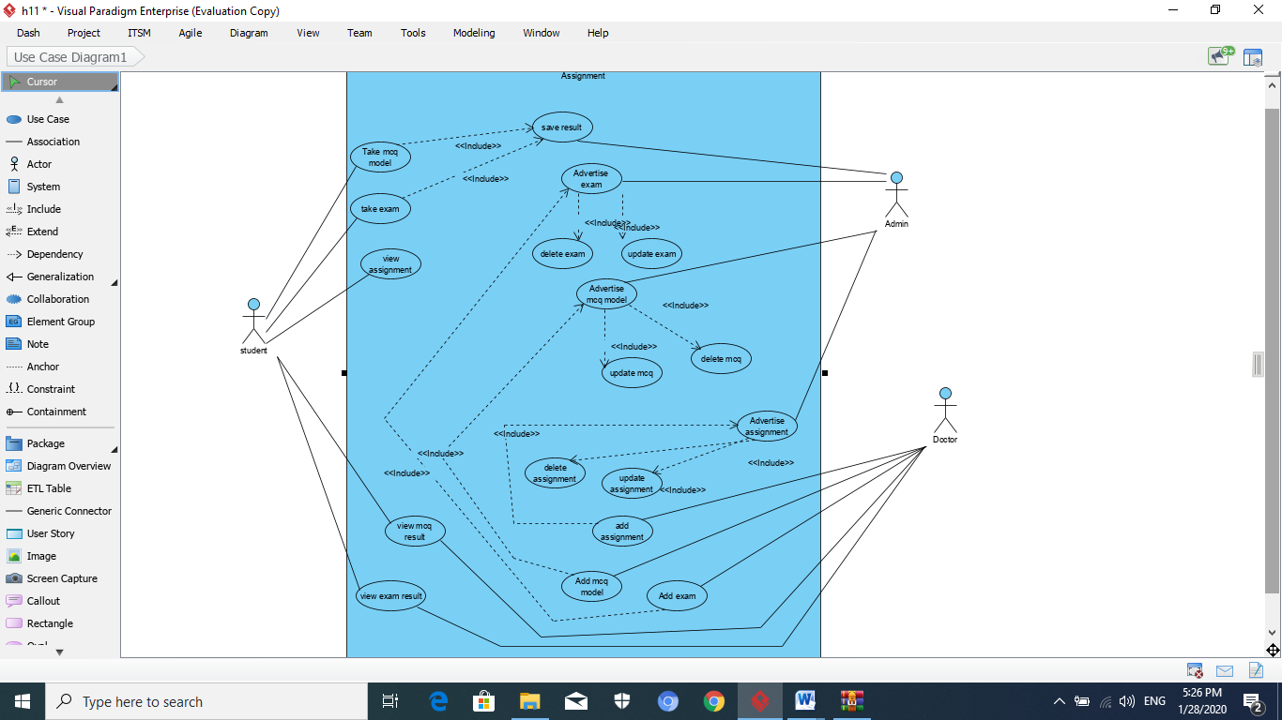

Figure 3.8.Assignment micro service use case diagram

Student wants to take mcq model to solve it and save his mark in the system or take an exam to solve it and as a result his marks will be saved in the system so, he will have all permissions to do these, also it has a permission to view his assignments in every course ,after solving an mcq or exam he view his results in both of them.

After student takes mcq or exam saving the students results is desirable , Admin actor will take all these permissions , he has the ability to advertise exams, mcq models and assignments in the system for all students as a result he can update or delete them also.

Doctor actor has permissions that allow him to add assignment, add mcq model or add exam as a result they will be advertised by the Admin actor as mentioned before. Also he has a permissions to view exam results or view mcq results.

### 3.8.2 Assignment sequence diagram

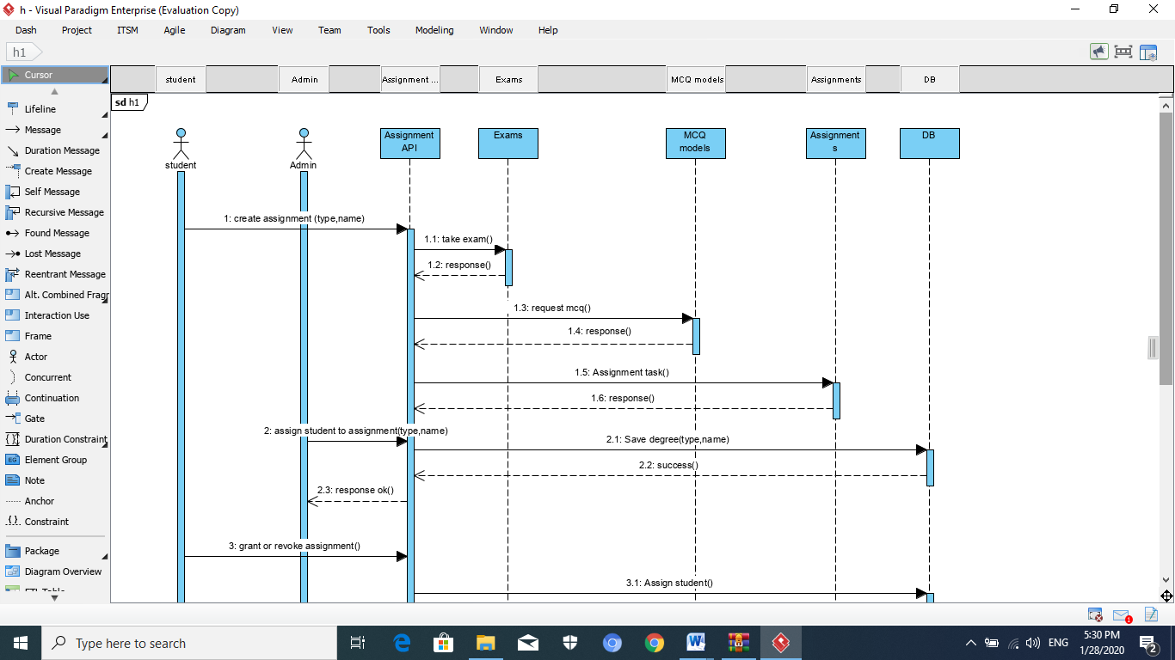

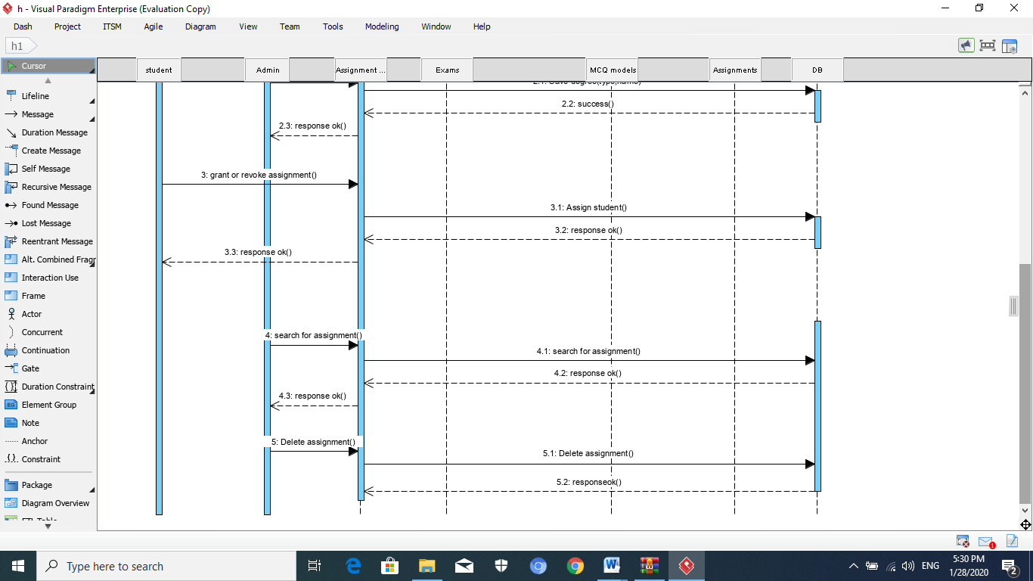

Figure 3.8.2Assignment micro service sequence diagram

This sequence will contains two actors :student ,Admin . Having an idea about the operations available for each user and the relations between them in use case diagram ,we are going to dig deeper and see how they are done, If students want to take an assignment they send an assignment message exciting the assignment type , depending on that type assignment can be either MCQ model , exam or assignment. After the student taking his assignment he needs to be assigned that he toke that assignment this will be done by the admin and saving his degree in DB. If student grant his assignment , Admin will assign the student in the DB for the assignment , Admin will be responsible for searching and deleting the assignment from the DB.

“All of these functions can be applied by interacting through Assignment API”.

# Chapter 4: Implementation

Focusing on how the difficulty you can create the APIs to be stable enough, So Why to use Dotnet Core as a main framework?

## 4.1 Why To Use .Net Core As A main Framework for APIs Development?

The **modularity** and **lightweight** nature of **.NET Core** makes it perfect for containers. When you deploy and start a container, its image is far smaller with .NET Core than with .NET Framework. In contrast, to use .NET Framework for a container, you must base your image on the Windows Server Core image, which is **a lot heavier** than the **Windows Nano Server** or **Linux images** that you use for .NET Core. [4]

Cross Platform

Nano Servers

Modularity

Lightweight

Additionally, .NET Core is cross-platform, so you can deploy server apps with Linux or Windows container images. However, if you are using the traditional .NET Framework, you can only deploy images based on Windows Server Core.

The following is a more detailed explanation of why to choose .NET Core.

### 4.1.1 Developing and deploying cross platform

Clearly, if your goal is to have an application (web app or service) that can run on multiple platforms supported by Docker (Linux and Windows), the right choice is **.NET Core**, because .NET Framework only supports Windows.

See the Differences on Figure 4.1.



Figure 4.1 .Net Framework Vs .Net Core

.NET Core also supports **macOS** as a development platform. However, when you deploy containers to a **Docker host**, that host must (currently) be based on Linux or Windows. For example, in a development environment, you could use a Linux VM running on a Mac. It’s still a viable choice see this Article [(5 REASONS WHY MICROSOFT STACK IS STILL A VIABLE CHOICE)](https://dotnetprofessionals.com.au/5-reasons-why-microsoft-stack-is-still-a-viable-choice/)

#### 4.1.1.2 The IDEs

**Visual Studio** provides an integrated development environment (IDE) for Windows and supports Docker development.

**Visual Studio for Mac** is an IDE, evolution of **Xamarin Studio**, that runs on **macOS** and supports Docker-based application development. This should be the preferred choice for developers working in Mac machines who also want to **use a powerful IDE.**

You can also use **Visual Studio Code (VS Code)** on **macOS**, **Linux**, and **Windows**. VS Code fully supports .NET Core, including IntelliSense and debugging. Because VS Code is a lightweight editor, you can use it to develop containerized apps on the Mac in conjunction with the Docker CLI and the .NET Core command-line interface (CLI). You can also target .NET Core with most third-party editors



### 4.1.2 Choosing Between .NET Core and .NET Framework for Docker Containers

like Sublime, Emacs, vi, and the open-source OmniSharp project, which also provides IntelliSense support.

In addition to the IDEs and editors, you can use the .NET Core CLI tools for all supported platforms.



Figure 4.3 Cross platform development of .Net Core

## 4.2 Start to Code

Using the .Net Core version 3.1.1 The Latest edition this time , showing the version and how to use The Power Shell to Create an API illustrated in figure 4.4



Figure 4.4 Creating an API from a Microsoft’s Templates

Showing How it work it’s simple to use first describing the program.cs file start the app from the file. So focusing now in the programming features of new development.

### 4.2.1 The Startup Class

The Startup class is where:

* Services required by the app are configured.
* The request handling pipeline is defined.

*Services* are components that are used by the app. For example, a logging component is a service. Code to configure (or *register*) services is added to the Startup.ConfigureServices method.



Figure 4.5 The Startup Class of .Net Core Web App

### 4.2.2 Dependency injection (services)

ASP.NET Core has a built-in dependency injection (DI) framework that makes configured services available to an app's classes. One way to get an instance of a service in a class is to create a constructor with a parameter of the required type. The parameter can be the service type or an interface. The DI system provides the service at runtime.

Here's a class that uses DI to get an MongoDB Bson driver context object. The highlighted line is an example of **constructor injection**:



Figure 4.6 The way to apply the constructor injection for MongoDB driver mapping

While DI is built in, it's designed to let you plug in a third-party Inversion of Control (IoC) container if you prefer.

For more information, see [Dependency injection in ASP.NET Core](https://docs.microsoft.com/en-us/aspnet/core/fundamentals/dependency-injection?view=aspnetcore-3.1).

### 4.2.3 Middleware

The request handling pipeline is composed as a series of middleware components. Each component performs asynchronous operations on an **HttpContext** and then either invokes the next middleware in the pipeline or terminates the request.

By convention, a middleware component is added to the pipeline by invoking its Use... extension method in the **Startup.Configure** method. For example, to enable rendering of static files, call **UseStaticFiles**.

The highlighted code in the following example configures the request handling pipeline in the illustrated Figure:



Figure 4.7 Using The Middleware as pipelines

ASP.NET Core includes a rich set of built-in middleware, and you can write custom middleware.

For more information, see [ASP.NET Core Middleware](https://docs.microsoft.com/en-us/aspnet/core/fundamentals/middleware/?view=aspnetcore-3.1).

### 4.2.4 Host

An ASP.NET Core app builds a host on startup. The host is an object that encapsulates all of the app's resources, such as:

* An HTTP server implementation
* Middleware components
* Logging
* DI
* Configuration

The main reason for including all of the app's interdependent resources in one object is lifetime management: control over app startup and graceful shutdown.

Two hosts are available: the Generic Host and the Web Host. The Generic Host is recommended, and the Web Host is available only for backwards compatibility.

The code to create a host is in Program.Main:



Figure 4.8 The Generic host that encapsulate all app’s resources

The **CreateDefaultBuilder** and **ConfigureWebHostDefaults** methods configure a host with commonly used options, such as the following:

* Use [Kestrel](https://docs.microsoft.com/en-us/aspnet/core/fundamentals/?view=aspnetcore-3.1&tabs=windows#servers) as the web server and enable IIS integration.
* Load configuration from ***appsettings.json***, ***appsettings****.{Environment Name}.json*, environment variables, command line arguments, and other configuration sources.
* Send logging output to the console and debug providers.

For more information, see [.NET Generic Host](https://docs.microsoft.com/en-us/aspnet/core/fundamentals/host/generic-host?view=aspnetcore-3.1).

**Non-web scenarios**

The Generic Host allows other types of apps to use cross-cutting framework extensions, such as logging, dependency injection (DI), configuration, and app lifetime management. For more information, see [.NET Generic Host](https://docs.microsoft.com/en-us/aspnet/core/fundamentals/host/generic-host?view=aspnetcore-3.1) and [Background tasks with hosted services in ASP.NET Core](https://docs.microsoft.com/en-us/aspnet/core/fundamentals/host/hosted-services?view=aspnetcore-3.1).

## 4.3 Implementing Swagger as A documentation for The API

When consuming a Web API, understanding its various methods can be challenging for a developer. [Swagger](https://swagger.io/), also known as [OpenAPI](https://www.openapis.org/), solves the problem of generating useful documentation and help pages for Web APIs. It provides benefits such as:

* interactive documentation
* client SDK generation
* API discoverability.

### 4.3.1 What is Swagger / OpenAPI?

Swagger is a language-agnostic specification for describing [REST](https://en.wikipedia.org/wiki/Representational_state_transfer) APIs.

The Swagger project was donated to the [OpenAPI Initiative](https://www.openapis.org/), where it's now referred to as OpenAPI. Both names are used interchangeably; however, OpenAPI is preferred. It allows both computers and humans to understand the capabilities of a service without any direct access to the implementation (source code, network access, documentation). One goal is to minimize the amount of work needed to connect disassociated services. Another goal is to reduce the amount of time needed to accurately document a service.

here are three main components to Swashbuckle:

* [Swashbuckle.AspNetCore.Swagger](https://www.nuget.org/packages/Swashbuckle.AspNetCore.Swagger/): a Swagger object model and middleware to expose SwaggerDocument objects as JSON endpoints.
* [Swashbuckle.AspNetCore.SwaggerGen](https://www.nuget.org/packages/Swashbuckle.AspNetCore.SwaggerGen/): a Swagger generator that builds SwaggerDocument objects directly from your routes, controllers, and models. It's typically combined with the Swagger endpoint middleware to automatically expose Swagger JSON.
* [Swashbuckle.AspNetCore.SwaggerUI](https://www.nuget.org/packages/Swashbuckle.AspNetCore.SwaggerUI/): an embedded version of the Swagger UI tool. It interprets Swagger JSON to build a rich, customizable experience for describing the web API functionality. It includes built-in test harnesses for the public methods.

Installing Them Using Nuget CLI or the Nuget previewer (The Package Manager of Dotnet) of Visual Studio



Figure 4.9 The installing of Swagger Component from nuget package manager

we must configure this service by implementing options pattern, and assigning the global variables in appsettings.json file, Creating option Repos and in it a helper class SwaggerOptions

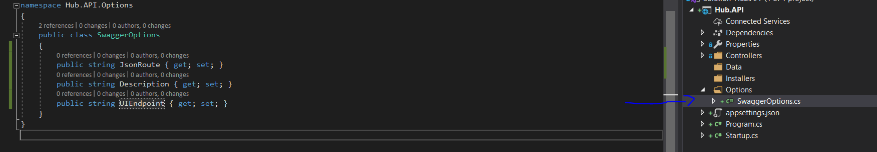

Figure 4.10 The Helper option class implementation

Then we need to associate the global variables of configuration file appsettings.json illustrated in the following figure

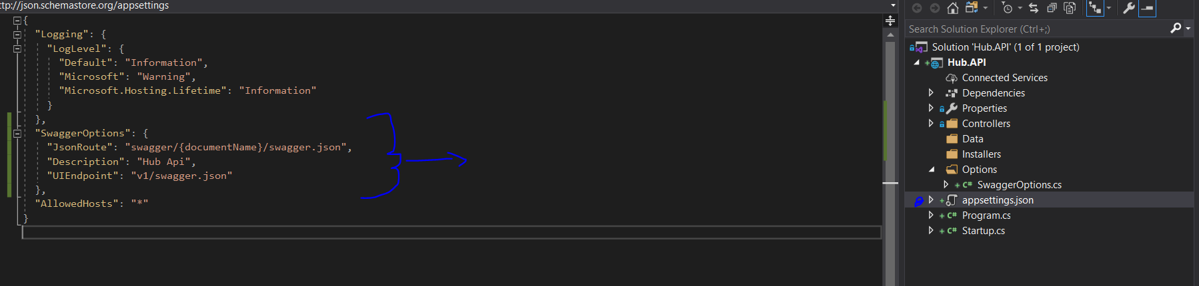

Figure 4.11 assigning the global variables in the configuration file of appsettings.json

Then we must associate the helper class with the global variables then install this middleware to the pipelines of work by creating an object from SwaggerOptions and **Binding** its variables from appsettings.json to swaggerOptions object



Figure 4.12 creating an object to receive the global variable from the configuration file

### 4.3.2 Add and configure Swagger middleware

Configure the middleware to options is done throw the middleware section by assigning each global variable into the right place



Figure 4.13 Configuration of 2 Middleware and using them after assigning the object values

The adding service to container to run in Runtime using services.AddSwaggerGen() method



Figure 4.14 Making it work at runtime

And by run now the application gotta it work:



Figure 4.15 Swagger UI first run before creating the api

## 4.4 Enabling CORS (Cross Origin Resource Sharing)

Browser security prevents a web page from making requests to a different domain than the one that served the web page. This restriction is called the same-origin policy. The same-origin policy prevents a malicious site from reading sensitive data from another site. Sometimes, you might want to allow other sites make cross-origin requests to your app. For more information, see the [Mozilla CORS article](https://developer.mozilla.org/en-US/docs/Web/HTTP/CORS).

[Cross Origin Resource Sharing](https://www.w3.org/TR/cors/) (CORS):

* Is a W3C standard that allows a server to relax the same-origin policy.
* Is **not** a security feature, CORS relaxes security. An API is not safer by allowing CORS. For more information, see [How CORS works](https://docs.microsoft.com/en-us/aspnet/core/security/cors?view=aspnetcore-3.1#how-cors).
* Allows a server to explicitly allow some cross-origin requests while rejecting others.
* Is safer and more flexible than earlier techniques, such as [JSONP](https://docs.microsoft.com/en-us/dotnet/framework/wcf/samples/jsonp).
* To Understand that see the figure 4.16



Figure 4.16 The Client Request from many servers(origin) as it Enabled for CORS

To allow any client app to request an origin, The CORS must be enabled, illustrated practically in following Figures 4.17, 4.18.



Figure 4.17 add the CORS component to the runtime as anyone in the world can consume now this API

It’s also can be enabled for some endpoints. Using the policy of **CorsPolicy** That is a mark to follow up.

Using only the LocalHost => 127.0.0.1 with only the port 4200 => the standard IP of Angular Application running.

There is a way to configure every method and every class lonely with its CORS policy by using the Packages of CORS illustrated in next figure.





Figure 4.18 use the component for the http pipeline

Notice that the function UseCors() must be between the UseRouting() and UseEndpoints() methods for not crashing

## 4.5 API Versioning Implementation

The Branching and versioning is the main backbone of agile processes, so the new versions have the enhancements but for some reason we go back to support many clients with oldest versions, versioning has the capability to make developers and stakeholders to show the past and make no confusion for the clients.

Once creating an API for a client, the client has a fear from the provider for no enhancing and maintenance

It’s a contract, API Must be versioned to keep up your clients’ support, a viable practice.

The versioning has 4 variables illustrated in the figure 4.19 starting from left to right:

* Changing of **The Major** seems that (The entire architecture has been updated⬄ Changed)
* Changing of **The Minor** seems that (only some sections have been updated or enhanced, or a bug fixed but this change must be broadcasted to client to know about it)
* Changing of **The Patch** seems that (a bug fixed, but the client needn’t know it)
* **Additional labels** for pre-release and build metadata are available as extensions to the **MAJOR.MINOR.PATCH** format.



Figure 4.19 The Versioning numeric/alphabetical logical system

Now by creating a new controller called **ChatController** for a scaffolding technique as a template it’s not versioned because the route is empty from the version route shown in the figure 4.20.



Figure 4.20 Not Versioned Controller from scaffolding an empty API controller template

### 4.5.1 How To Versioning

A simple way to create many controllers with different versions but it’s a bad practice illustrated in following figures

Figure 4.21 Bad practice of Versioning

so let’s find a way, first Creating a folder [V1] in the Controller folder to have all version 1 controllers then moving the ChatController inside it. Secondly creating a folder for Contracts to contain the reason of versioning as shown in figure 4.22:

* ApiRoutes sharing routes versions

Figure 4.22 The Versioning folders

* Requests View Models
* Responses View Model

Don’t forget to change the namespace name while moving for no confusion(Hub.Controllers.V1), trying now to create some routes to the chat API to use them in ChatController.cs , making a class called ApiRoutes.cs containing many internal static classes {Chat , Notification}, each class is logically mapped to a controller, ApiRoutes contain many constant values that encapsulate routes shown as figure 4.23.

Figure 4.23 The ApiRoutes Class for versioning

Now moving to check versioned classes to controller by making a fake operation calling in the API Get HttpGet route ([HttpGet(ApiRoutes.Chat.GetChannel)]) to check out the compatible swagger interact with the versioned classes illustrated in figure 4.24.



Figure 4.24 Fake operation to get some data from API

So the result work on Swagger perfectly illustrated in Figure 4.25.



Figure 4.25 Checking for results

## 4.6 Dependency Injection and Clear service Registeration

Logically it’s not accepted to register all the services in one method, make this method have multiple responsibilities and this attack the SOLID principles of Single Responsibility Principle (SRP) make it not clear architecture and lose its performance and a single point of failure, it’s the default way shown at figure 4.26.

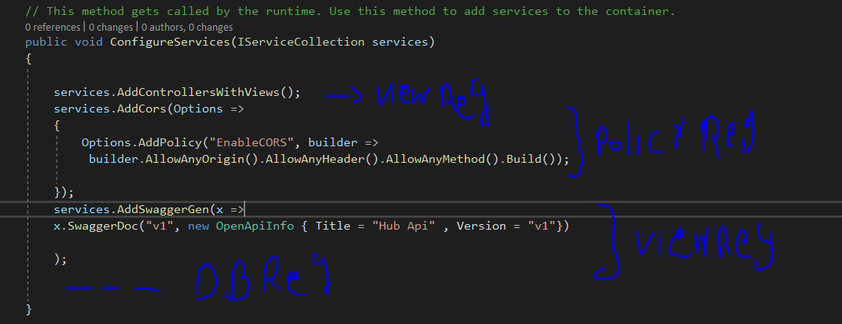

Figure 4.26 Heterogeneous services registered in one method place Bad practice

### 4.6.1 Implementing Separation of concerns in DI SOLID (Single Responsibility Princible)

First creating a folder for services to registered in (Installers) and has an Interface (IInstaller) for Dynamic Binding to all services for Dependency Injection

The interface has a method to be overridden is InstallServices() shown in figure 4.27.



Figure 4.27 Interface for installing services

Second moving every register from the Startup class to its class type of installers by implementing many classes inherit from interface of IInstaller illustrated in the following figures.



Figure 4.28 The View Installer contains registers of view types



Figure 4.29 The Policies installer contains register of CORS



Figure 4.30 The DB Installer using for future use of DBs

Then Actually must assign all services to the main configuration by getting all in a loop shown in a figure



Figure 4.31 Configure all registers

### 4.6.2 Achieve The OCP Solid Principle (Open for Extension Closed for Modification)

To make the installers means to the OCP in SOLID principles (Open for extension and closed for modification) a clear code must contain the extensibility for that Creating a static class (InstallerExtensions) which agree with the OCP principle by accept an extension method for atomicity of code and moving the code from the registered services in startup class to the extension one shown in figure 4.32.

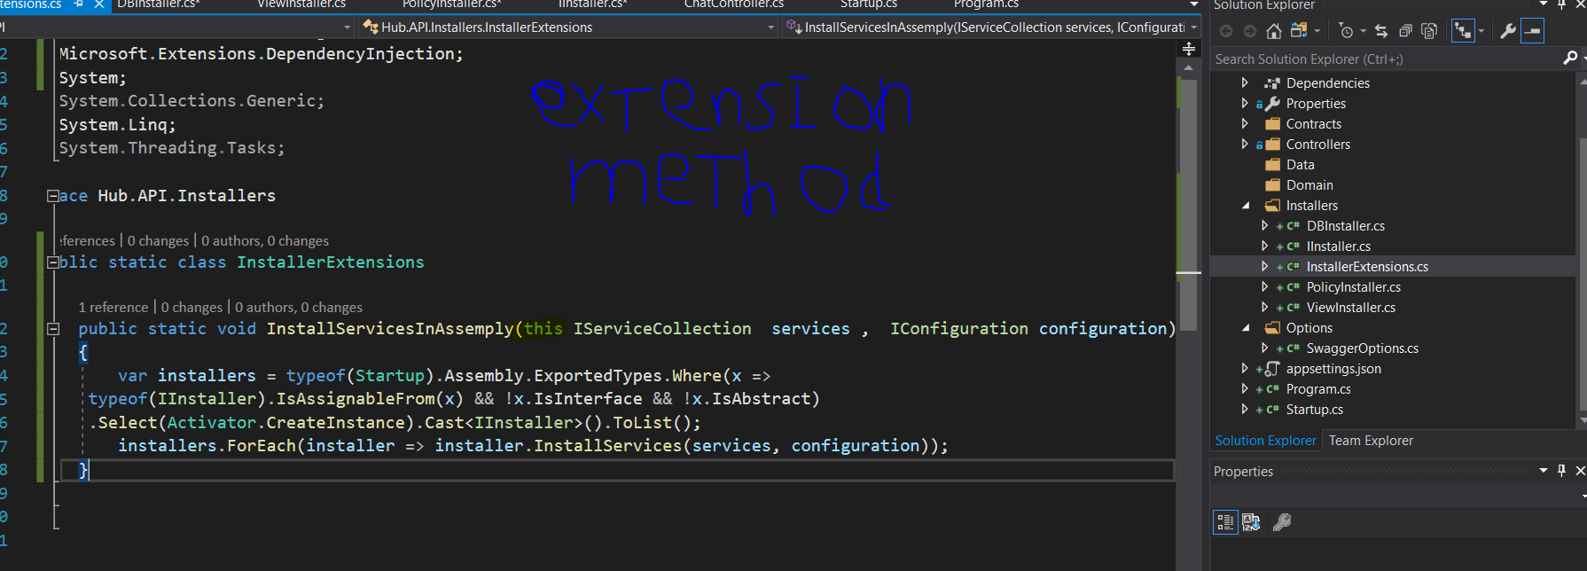

Figure 4.32 Extension method to apply any service registered

Now calling the method as one of the services object method from the startup shown in the figure 4.33.

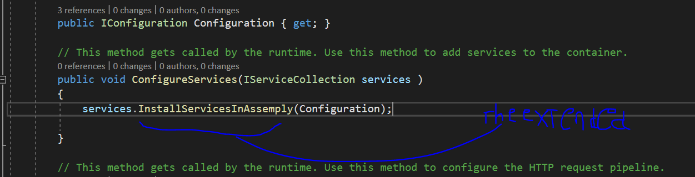

Figure 4.33 Calling the extended method from services object.

## 4.7 NoSql(OODB) vs Sql(RelationalDB) in Design (Which one do i choose?)

Before starting the challenge between NoSQL and SQL, it must show to us easily more, because of relational DB use a DBMS that define schemes to manipulates these types and using many layer to manage the retrieve and write the data. These things make overheads that decrease the performance but it’s secure enough as a paradigm to keeps our data safe and persistent, these schemes are not found in NoSQL paradigms which means high performance and scalable as you go.

Let’s define each one and show the trends today:

### 4.7.1 What is SQL?

Structured Query language (SQL) **pronounced as "S-Q-L" or sometimes as "See-Quel**" is the standard language for dealing with Relational Databases. A relational database defines relationships in the form of tables.

SQL programming can be effectively used to insert, search, update, delete database records. [9]

That doesn't mean SQL cannot do things beyond that. It can do a lot of things including, but not limited to, optimizing and maintenance of databases. [9]

Relational databases like MySQL Database, Oracle, Ms SQL Server, Sybase, etc. use SQL. [9]

It’s good for an OLAP when need of more analytics than OLTP when need more transactions, and good choice when need more secure data so this project use the SQL SERVER as the DB of Identity Microservices, seems less transactions for creating account or registering and login, these are one time operation by session.

Need more info see this [video](https://youtu.be/FR4QIeZaPeM), The Schema of relational Db seems like figure 4.34.



Figure 4.34 The Schema of a SQL DB

### 4.7.2 What is NoSQL?

NoSQL is a non-relational DMS, that does not require a fixed schema, avoids joins, and is easy to scale. NoSQL database is used for distributed data stores with humongous data storage needs. NoSQL is used for Big data and real-time web apps. For example companies like Twitter, Facebook, Google that collect terabytes of user data every single day.

NoSQL database stands for "Not Only SQL" or "Not SQL." Though a better term would NoREL NoSQL caught on. Carl Strozz introduced the NoSQL concept in 1998.

Traditional RDBMS uses SQL syntax to store and retrieve data for further insights. Instead, a NoSQL database system encompasses a wide range of database technologies that can store structured, semi-structured, unstructured and polymorphic data. [9]

So microservices is a good way to implement the 2 ways together because it uses the **single database per service design pattern** as shown as in the Architecture figure, choosing the MS SQL Server (SQL Type) for the Identity Microservices (login and register and user management) and the MongoDb for the other Microservices illustrated in the Figure 4.35.



Figure 4.35 The Architecture show the Heterogeneity of using SQL/NoSQL DBs (MS SQL Server and MongoDb)

### https://www.guru99.com/images/1/101818_0550_Differenceb2.png 4.7.3 ACID vs BASE

Figure 4.36 The ACID and BASE properties

**Acids and Bases** are one of the most important parts of chemistry, but also play their significant role in another field of science. There are many definitions which differentiate the substances as acid and base, but the most accepted are the Arrhenius theory, Bronsted-Lowry theory and the Lewis theory of acid/base. Together acids and bases react to form salts.

But when going to the concept of databasing it’s just the properties of how transactions must operate and don’t violate these models, ACID is Stands for (Atomicity – Consistency – Isolation - Durability) this is RDBMS gold standard and every book or reference talking about the RDBMS must talk about it, also BASE is like that in OODBMS (object oriented DBMS) such as any NoSQL driver, BASE is stands for (Basically Available – Soft state – Eventually consistent) let’s show what is meaning showing in figure

**The ACID Consistency Model**

Many developers are familiar with ACID transactions from working with [relational databases](https://neo4j.com/whitepapers/rdbms-developers-graph-databases-ebook/?ref=blog). As such, the ACID consistency model has been the norm for some time.  
  
The key ACID guarantee is that it provides a safe environment in which to operate on your data. The ACID acronym stands for:  
  
***Atomic***

* + All operations in a transaction succeed or every operation is rolled back.

***Consistent***

* + On the completion of a transaction, the database is structurally sound.

***Isolated***

* + Transactions do not contend with one another. Contentious access to data is moderated by the database so that transactions appear to run sequentially.

***Durable***

* + The results of applying a transaction are permanent, even in the presence of failures.

ACID properties mean that once a transaction is complete, its data is consistent (tech lingo: write consistency) and stable on disk, which may involve multiple distinct memory locations. [10]

**The BASE Consistency Model**

For many domains and use cases, ACID transactions are far more pessimistic (i.e., they’re more worried about data safety) than the domain actually requires.  
  
In the NoSQL database world, ACID transactions are less fashionable as some databases have loosened the requirements for immediate consistency, data freshness and accuracy in order to gain other benefits, like scale and resilience.  
  
(Notably, the .NET-based [RavenDB](https://ravendb.net/" \t "_blank) has bucked the trend among aggregate stores in supporting ACID transactions.)  
  
Here’s how the BASE acronym breaks down:  
  
***Basic Availability***

* + The database appears to work most of the time.

***Soft-state***

* + Stores don’t have to be write-consistent, nor do different replicas have to be mutually consistent all the time.

***Eventual consistency***

* + Stores exhibit consistency at some later point (e.g., lazily at read time).

BASE properties are much looser than ACID guarantees, but there isn’t a direct one-for-one mapping between the two consistency models (a point that probably can’t be overstated).  
  
A BASE data store values availability (since that’s important for scale), but it doesn’t offer guaranteed consistency of replicated data at write time. Overall, the BASE consistency model provides a less strict assurance than ACID: data will be consistent in the future, either at read time or it will always be consistent, but only for certain processed past snapshots. [10]

The SQL DBs is Scalable Vertically means the performance is Decreased

The NoSQL DBs is Scalable Horizontally means the performance is constant but less restrictions over consistency.

Last thing would exist here is all have their advantages and drawbacks but the judgement is kept on eyes, you can find many ways to same goal and you can optimize them.

## 4.8 NOSQL MongoDb Accepting in .Net Environement (OODB)

The project use MongoDb to many reasons:

* Aggregation Framework
* BSON Format
* Sharding
* Ad-hoc Query
* Capped Collection
* Indexing
* File Storage
* Replication
* MongoDB Management Service (MMS)

### 4.7.1 Working WIth MongoDb

Let’s test the environment of the mongo, running from CLI or the Compass after installing it, using the [web shell](https://docs.mongodb.com/manual/tutorial/getting-started/) or open the community edition and try the commands to test by creating a collection (Channels) showing in figure 4.37.



Figure 4.37 Mongo Web Shell testing environments creating a collection channels

By Inserting the 2 objects and the driver reply with acknowledgement of true success and generate 2 Ids



Figure 4.38 Inserting 2 objects in the Channel Collection

Then retrieving again, the objects of JSON structure **pretty.**



Figure 4.39 retrieving back the objects created

### 4.7.2 Installing the Mongo Services into .Net Environment

Now let’s connect the middleware to the environment of Hub Microservice API, Installing the Middleware from nugget package manager the (Mongo.Driver, Mongo.BSON) illustrated in figure 4.40.



Figure 4.40 Installing mongo component to .Net Environment

Then Configuring the application by defining the environment variables of database that must take in account when manipulating the mongo driver showing create of 2 collections (Channels, Notification) in 2 objects in appsettings.json file illustrated in figure 4.41.

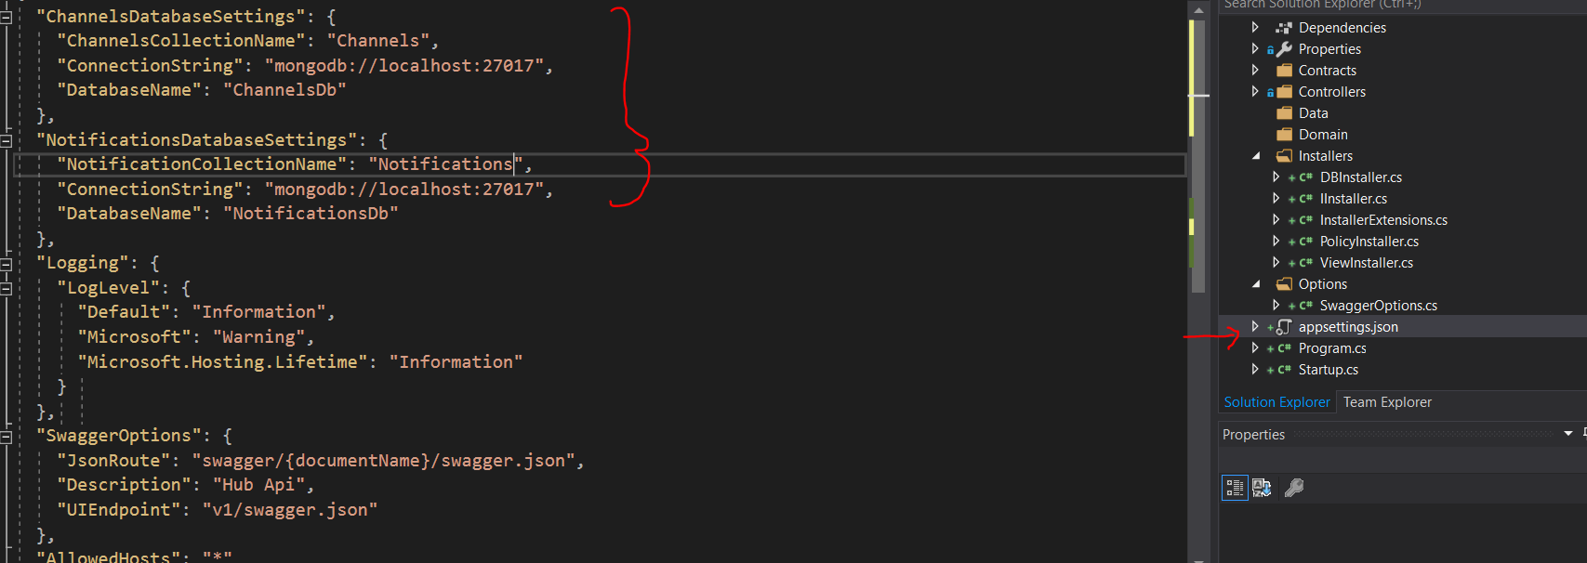

Figure 4.42 Inserting the environment variables for 2 collection of Dbs (NotificationsDb, ChannelsDb)

Then creating the configuration models for accepting these variables to middleware, The JSON and C# property names are named identically to ease the mapping process illustrated in figures 4.43, 4.44.



Figure 4.43 Creating the Configuration model class for NotificationDb variables



Figure 4.44 Creating the Configuration model class for ChannelsDb variables

Now registering the services to installers and map the JSON properties to its C# variables using the unused class of DBInstaller.cs then adding the singleton pattern to consume it from only one object for each database illustrated in figure 4.45.



Figure 4.45 Configuring the Mapping and adding the singleton object to each database

### 4.7.3 Isolating The Business Logic from API Controllers

The versioned controllers have complexity to control all the business logic of the application and it can contain many functionalities repeated so to keep it clean, adding dependency injection from the business logic to make it easy for controllers, then applying dependency injection to inject these services in controllers, best practice to do it shown in figures 4.46, 4.47.



Figure 4.46 Dependency injection of Business Logic Chatting service



Figure 4.47 Dependency injection of Business Logic Notification service

### 4.7.4 Creating Business Logic by applying DI of Mongo.Drive middileware

Working as Microservices, it’s must apply one of critical paradigms that measures the human being’s nature for his needs, wants, it’s like the user stories order server and the backend is serve, this is a design pattern called Backend for frontend design pattern (BFF design pattern) and from that making the whole business from the visions of human beings showing in figure 4.48.



Figure 4.48 The Backend for frontend Design pattern technique

And for that, must take in account the routes back to **Contracts folder** and modifying the ApiRoutes.cs by analysis it shown that routes become such figure 4.49.

# CHAPTER 5: REAL-TIME Services Implementation

The new paradigms of systems need to be based upon the real time services, real-time means the realistic interaction of components like the world is real-time, any change must be observable to clients in the real-time but these types of services don’t depend in the client-server architecture so they use new design patterns to handle these changes automatically, most of the browser support web sockets communication illustrated in the figure 5.1 and to following updates [click this link](https://caniuse.com/#feat=websockets).



Figure 5.1 The Web Socket supported browsers (Bidirectional Communication).

## 5.1 Http, The Client in Real-Time, The Client is the Boss

An HTTP operation is based on a **request-response schema**, which is always started by the client. This procedure is often referred to as the **pull model**: When a client needs to access a resource hosted by a server, it purposely initiates a connection to it and requests the desired information using the “language” defined by the HTTP protocol. The server processes this request, returns the resource that was asked for (which can be the contents of an existing file or the result of running a process), and the connection is instantly closed.[11]

### 5.1.1 Traditional Reques-Response Model

This paradigm is often used in every request the client do through the internet when requesting a web page containing Multimedia contents, request the item from the server by http then server listen to the request and process it to create the desired response then sending to the browser what client requested then connection closed. This is the traditional way of request-response schema illustrated in figure 5.2.



Figure 5.2 The Request-Response Schema of traditional client-server Architecture

### 5.1.2 Continuous Request-Response over same Page (AJAX)

The HTTP protocol itself can support the needs for asynchrony of modern applications, owing to the techniques generally known as **AJAX (Asynchronous JavaScript And XML)**.

Using AJAX techniques, the exchange of information between the client and the server can be done without leaving the current page. At any given moment, the client can initiate a connection to the server by using JavaScript, request a resource, and process it (for example, updating part of the page).

What is truly advantageous and has contributed to the emergence of very dynamic and interactive services, such as Facebook or Gmail, is that these operations are carried out asynchronously—that is, the user can keep using the system while the latter communicates with the server in the background to send or receive information.



Figure 5.3 AJAX handles the continuous requesting model.

This operating schema continues to use and abide by the HTTP protocol and the client-driven request-response model. The client is always the one to take the initiative, deciding when to connect to the server illustrated in figure 5.3.

But it is not solving the problem of real-time systems, someone can tell AJAX can handle it, but not true, they operate it like polling technique, but this is another design pattern to allow real-time, let’s cover all these design pattern to choose which is the idle.

### 5.1.3 Real-Time Services Design Patterns & Techniques

The reason is simple: **HTTP is not oriented to real time**. There are other protocols, such as the popular **IRC2**, which are indeed focused on achieving **swifter communication** to offer more dynamic and interactive services than the ones we can obtain **using pull**. In those, the server can take the initiative and send information to the client at any time, without waiting for the client to request it expressly.

#### 5.1.3.1 Polling: The answer?

Figure 5.5 Polling technique.

As web developers, when we face a scenario in which we need the server to be the one sending information to the client on its own initiative, the first solution that intuitively comes to our minds is to use the technique known as polling. Polling basically consists in making periodic connections from the client to check whether there is any relevant update at the server, as shown in Figure 5.4.

It’s the simplest way to perform the real-time because it’s still http requests, and it’s just a pulling not more.

The cost of polling technique is significantly huge, as it’s proportionally increase with clients increase, imagine that you have 300,000 users chats to many users of them and groups, you can’t imagine what is the disaster of this problem. If everyone has 10 rooms and the polling every 3 seconds then the requests to server would be for only the chats 1,000,000 request per second, and you can have only a question (What is the type of network can observe them?)

#### 5.1.3.2 Push: The server takes the initiative

There are applications where the use of pull is not very efficient. Among them, like instant-messaging systems, real-time collaboration toolsets, multiuser online games, information broadcasting services, and any kind of system where it is necessary to send information to the client right when it is generated.

This is precisely the idea behind the push, or server push, concept. This name does not make reference to a component, a technology, or a protocol: it is a concept, a communication model between the client and the server where the latter is **the one taking the initiative in communications**.[11]

This concept is not new. There are indeed protocols that are push in concept, such as **IRC** illustrated in figure 5.6, the protocol that rules the operation of classic chat room services, or **SMTP (Mail protocol)** illustrated in figure 5.7, the protocol in charge of coordinating email sending. These were created before the term that identifies this type of communication was coined.



Figure 5.6 IRC protocol model working.

Figure 5.7 SMTP working model

Nevertheless, push is something that we need right now. Users demand ever more interactive, agile, and collaborative applications. To develop them, we must make use of techniques allowing us to achieve the immediacy of push but taking into account current limitations in browsers and infrastructure. At the moment, we can obtain that only by making use of the advantages of HTTP and its prevalence.

Given these premises, it is easy to find multiple conceptual proposals on the Internet, such as Comet, HTTP push, reverse AJAX, AJAX push, and so on, each describing solutions (sometimes coinciding) to achieve the goals desired. In the same way, we can find different specific techniques that describe how to implement push on HTTP more or less efficiently, such as long polling, XHR streaming, or forever frame.

#### 5.1.3.3 WebSockets

The WebSockets standard consists of a development API, which is being defined by the W3C (World Wide Web Consortium, http://www.w3.org), and a communication protocol, on which the IETF (Internet Engineering Task Force, http://www.ietf.org) has been working.

Basically, it allows the establishment of a persistent connection that the client will initiate whenever necessary and which will remain open. A two-way channel between the client and the server is thus created, where either can send information to the other end at any time.



Figure 5.8 The WebSockets working model

From the perspective of a developer, WebSockets offers a JavaScript API that is really simple and intuitive to initiate connections, send messages, and close the connections when they are not needed anymore, as well as events to capture the messages received:



Figure 5.9 Implementing web sockets in Java Script

Actually, this implementation of websockets will be focused in the next section.

#### 5.1.3.4 Server-Sent Events (API Event Source)

Server-Sent Events, also known as API Event Source, is the second standard on which the W3 consortium has been working. Currently, this standard is in candidate recommendation state. But this time, because it is a relatively straightforward JavaScript API and no changes are required on underlying protocols, its implementation and adoption are simpler than in the case of the WebSockets standard.

In contrast with the latter, Server-Sent Events proposes the creation of a one-directional channel from the server to the client, but opened by the client. That is, the client “subscribes” to an event source available at the server and receives notifications when data are sent through the channel, Illustrated in the figure 5.10.



Figure 5.10 The API Event source model working

All communication is performed on HTTP. The only difference with respect to a more traditional connection is the use of the content-type text/event-stream in the response, which indicates that the connection is to be kept open because it will be used to send a continuous stream of events or messages from the server.

#### 5.1.3.5 Long polling

A push technique, but is quite similar to the polling with modification to optimize the efficiency and immediacy of communication.

The client also polls for updates, but, unlike in polling, if there is no data pending to be received, the connection will not be closed automatically and initiated again later. In long polling, the connection remains open until the server has something to notify, illustrated in figure 5.11.



Figure 5.11 Long polling technique

Resource consumption with long polling is somewhat higher than with other techniques where a connection is kept open. The reason is that there are still many connection openings and closures if the rate of updates is high, not forgetting the additional connection that has to be used when the client wants to send data to the server. Also, the time it takes to establish connections means that there might be some delay between notifications. These delays could become more evident if the server had to send a series of successive notifications to the client. Unless we implemented some kind of optimization, such as packaging several messages into one same HTTP response, each message would have to wait to be sent while the client received the previous message in the sequence, processed it, and reopened the channel to request a new update.

#### 5.1.3.6 Forever frame

The other technique is called forever frame and uses the HTML <IFRAME> tag cleverly to obtain a permanently open connection. In a way, this is very similar to Server-Sent Events.

Figure 5.12 The forever frame technique.

Broadly, it consists in entering an <IFRAME> tag in the page markup of the client. In the source of <IFRAME>, the URL where the server is listening is specified. The server will maintain this connection permanently open (hence the “forever” in its name) and will use it to send updates in the form of calls to script functions defined at the client. In a way, we might say that this technique consists in streaming scripts that are executed at the client as they are received illustrated in figure 5.12.

### 5.1.4 The world needs more than just push

Until now, we have seen techniques that allow us to achieve push; that is, they allow the server to be able to send information to the client asynchronously as it is generated. We have given the initiative to an element that would normally assume a passive role in communications with the client. However, in the context of asynchronous, multiuser, and real-time applications, push is but one of the aspects that are indispensable. To create these always surprising systems, we need many more capabilities. Here we list a few of them:

* **Managing connected users:** The server must always know which users are connected to the services, which ones disconnect, and, basically, it must control all the aspects associated with monitoring an indeterminate number of clients.
* **Managing subscriptions:** The server must be capable of managing “subscriptions,” or grouping clients seeking to receive specific types of messages. For example, in a chat room service, only the users connected to a specific room should receive the messages sent to that room. This way, the delivery of information is optimized and clients do not receive information that is not relevant to them, minimizing resource waste.
* **Receiving and processing actions**: The server be capable not only of sending information to clients in real time but also of receiving it and processing it on the fly to check what is the data contain.
* **Monitoring submissions**: Because we cannot guarantee that all clients connect under the same conditions, there might be connections at different speeds, line instability, or occasional breakdowns, and this means that it is necessary to provide for mechanisms capable of queuing messages and managing information submissions individually to ensure that all clients are updated.
* **Offering a flexible API**, capable of being consumed easily by multiple clients This is even truer nowadays, when there are a wide variety of devices from which we can access online services.

enumerating many more, but these examples are more than enough to give an idea of the complexity inherent in developing these types of applications.

## 5.2 SignalR CHAT Development

Have more fun with these libraries that can develop more than a system but a life.

### 5.2.1 Introducing SignalR

**SignalR** is a library from **Microsoft** that offers real-time web development for ASP.NET applications.

SignalR is primarily used by applications that require push notifications from server to client; for example, applications such as **chat, stock market, gaming, and dashboards**.

Prior to SignalR, application developers used to implement real-time web functionalities by using **pooling methods** such as **long/short polling** in which a client will poll the server for new information based on a time interval illustrated the other techniques in previous sections.

This approach is always performance intense, network offensive, and requires more hardware. SignalR solves the problem by providing a **persistent connection** between the client and the server. It uses the **Hubs API** to push notifications from server to client, and it supports **multiple channels such as WebSocket, server-sent events, and long polling in abstraction level illustrated in figure 5.13**.



Figure 5.13 the API Abstractions of SignalR

SignalR supports multiple clients ranging from C#/C++ to JavaScript. SignalR supports SQL Server, Redis, Azure Service Bus, and more to achieve scalability.

As the development paradigm shifts toward ASP.NET Core, Microsoft is redesigning and rebuilding its traditional SignalR to support a new ASP.NET Core framework.

The new SignalR is a complete rewrite from scratch, because ASP.NET Core has a lot of new features such as new HttpContext, dependency injection, and configuration. At the same time, the .NET Core’s SignalR version should be portable with the .NET Standard. Some of the new changes in the latest SignalR for .NET Core are as follows:

* No dependency on JQuery. This will make the new SignalR run on the client side without JQuery references. The ASP.NET Core team plans to use most of the default features of the latest browsers.
* Hubs are mapped to routes, through which the single connection dependency was removed. Different clients can connect to hubs of their choice through different URLs.
* Just like traditional SignalR, the new version also supports WebSocket, server-sent events, and long polling transport types.
* Extensive support for binary data.
* The new SignalR will implement a new scale-out design that is more flexible than the existing one.
* User presence support, which can be used to track a user’s lost or idle connections.
* The reconnection feature from traditional SignalR has been removed because of memory leaks and complicated unnecessary logic inside SignalR to make sure messages are durable.
* Traditional SignalR was used to allow clients to change servers between reconnections, but in new SignalR except WebSocket, all other connections require sticky sessions.

### 5.2.2 Implementing signalR

First it must be installed from nuget package manager the Microsoft.AspNetCore.SignalR component and Microsoft.AspNetCore.SignalR.Core as illustrated in figure 5.14.



Figure 5.14 SignalR nuget packages to install.

### 5.2.3 Angular Application to consume Chat services

#### Installing prerequested packages & Libraries

Now, by creating the angular app using the Node JS package manager, now using the angular CLI to install required packages:

* **Bootstrap 4**: is an open source toolkit for developing with HTML, CSS, and JS. To develop responsive grid system, extensive prebuilt components, and powerful plugins built on jQuery.
  + **$ npm install bootstrap --save**
* **JQuery**: First,It must be installed as the Bootstrap is built on it, the JQuery, jQuery is a fast, small, and feature-rich JavaScript library. It makes things like HTML document traversal and manipulation, event handling, animation, and Ajax much simpler with an easy-to-use API that works across a multitude of browsers. With a combination of versatility and extensibility, jQuery has changed the way that millions of people write JavaScript.
  + **$ npm i JQuery@1.9.1 --save**
* **Popper**.js: Given an element, such as a button, and a tooltip element describing it, Popper will automatically put the tooltip in the right place near the button. It will position any UI element that "pops out" from the flow of your document and floats near a target element. The most common example is a tooltip, but it also includes popovers, drop-downs, and more. All of these can be generically described as a "popper" element.
  + **$ npm i @popperjs/core --save**
  + **$ npm I popper.js --save**
* **SignalR:** Can be Integrated with the frontend application to ease use the ASPNET signalr services
  + **$ npm install @aspnet/signalr –save**

#### Configuring The Frontend Packages

Now, configuring these libraries and packages with the application, going to angular.json file to make use of them.

Configuring the 3 packages of frontend {Bootstrap 4 , Jquery , Popper.js} globally for all application, it’s come from the angular.json file, the main file of configuration illustrated in figure 5.15.

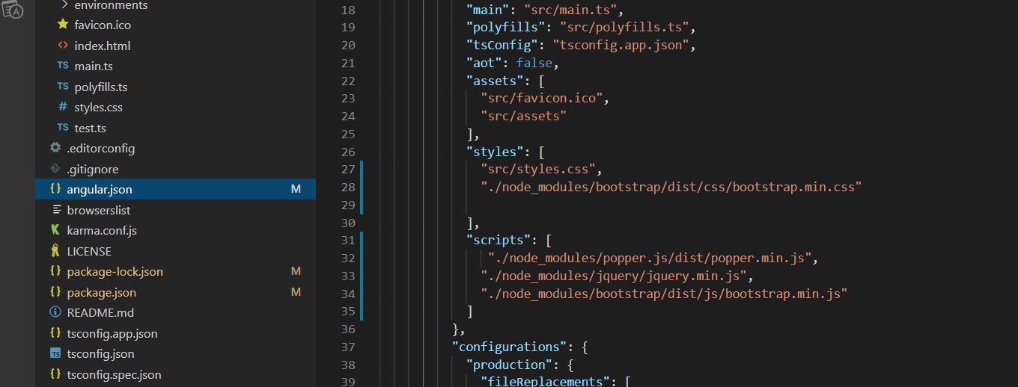

Figure 5.15 configuring the UIs packages

The packages need to be configured to all components as style sheets or Java scripts so in angular.json file adding to the styles array the path of the bootstrap CSS file and in scripts mapping the files by passes too, but it must be arranged because the call of methods come from bottom files to upper and the styles override, be aware.

#### Generating UI component to receive who is the USer

The Application is created now, to simulate the chatting rooms between the users so first, creating a page to know who is the user first.

So, creating new component called login to receive the id from user using the following command:

**$ ng generate component login**

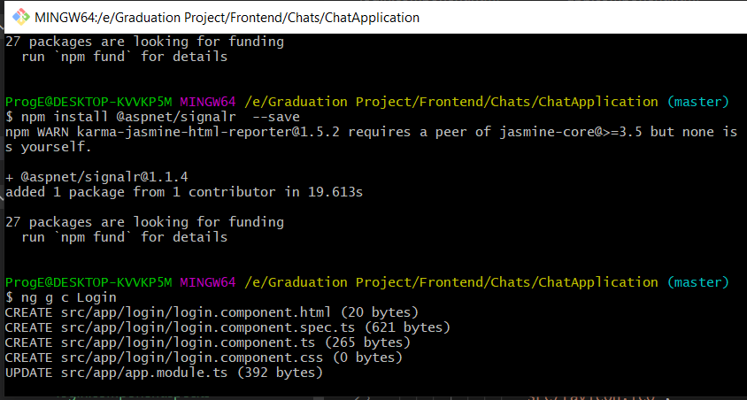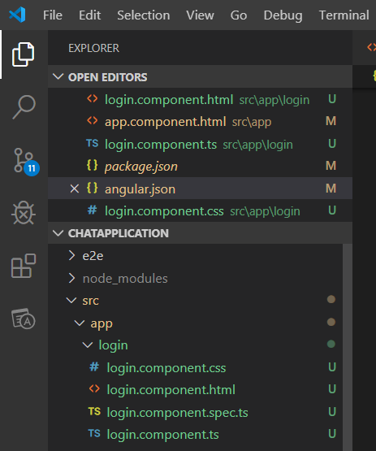

Figure 5.16 Generating login component as a UI module to work with.

Running this command generates a folder with 4 files:

* The Html component: the structure and the elements of the page.
* The CSS component: the style sheet where we write the CSS elements.
* The Spec TS file: where the component can be tested as a unit.
* The TS file: mapping the application services to the components (gets and sets parameters, control the UI Component…)

By writing the CSS and The Html of Login component illustrated in figure 5.17 and run the application using command:

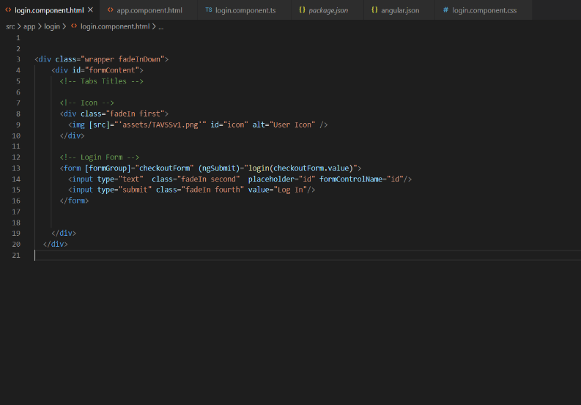**$ ng serve -o**

Figure 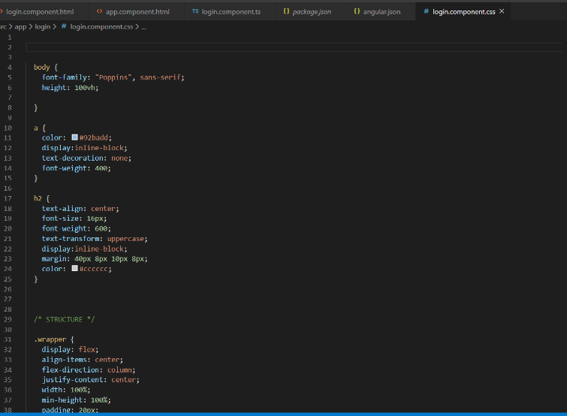5.17 Typing the styles and the Html Contents

Adding the logo of TAVSS app in the assets to run with logo.

Then now calling the component in the main component to make it feasible.

Now illustrating the figure of running in 5.18.

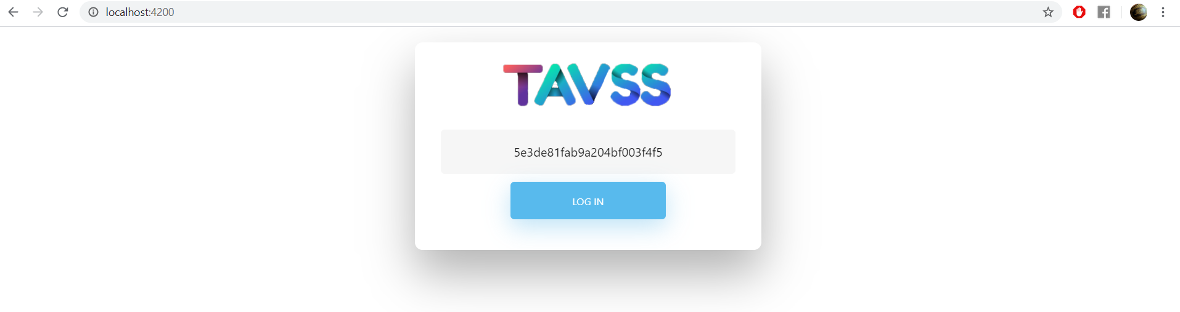

Figure 5.18 The UI running result.

#### The Backend side of Chatting app

Now, going to code the backend side to receive the id then respond with the channels of user.

Using the Versioning design pattern to control the directions of the application, and creating the routes of controller by The ApiRoutes.cs file as static mempers to call shown at figure 5.19.

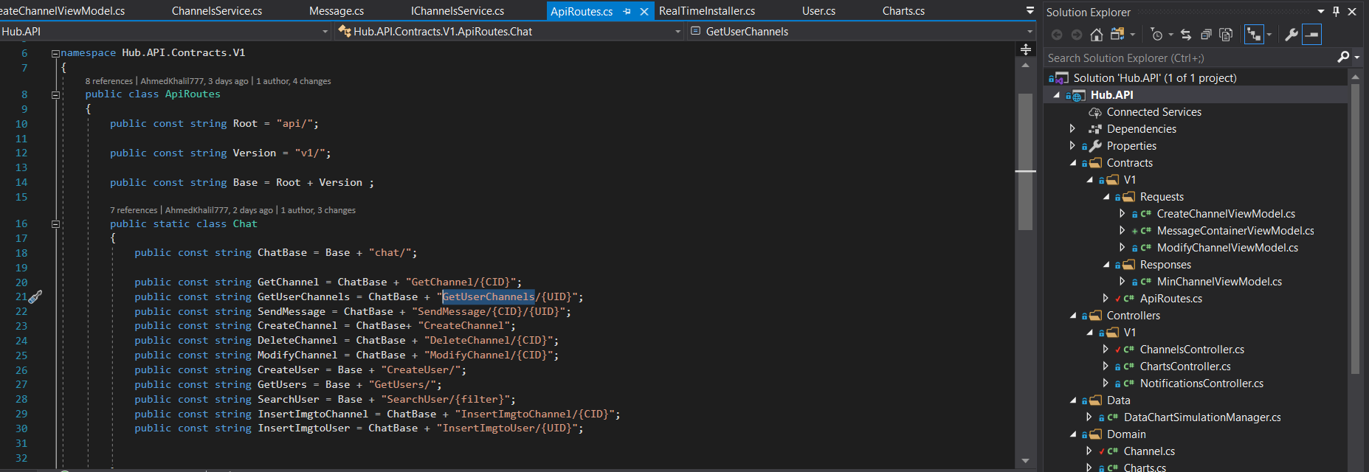

Figure 5.19 The API Routes of Backend definitions.

Then creating the data access models of mongo DB to manipulate the data come from the server of mongo and map the ids as a BSON Ids, creating 2 pages illustrated in figure 5.20:

* The Channel Collection: [Messages, Users, Meta data of the channel]
* The User Collection: [Id, name, …….]

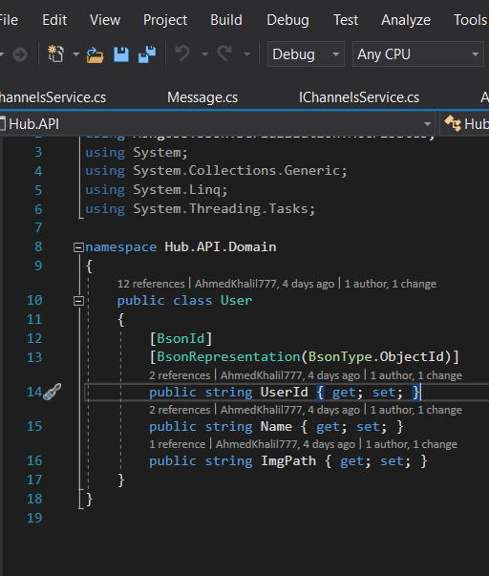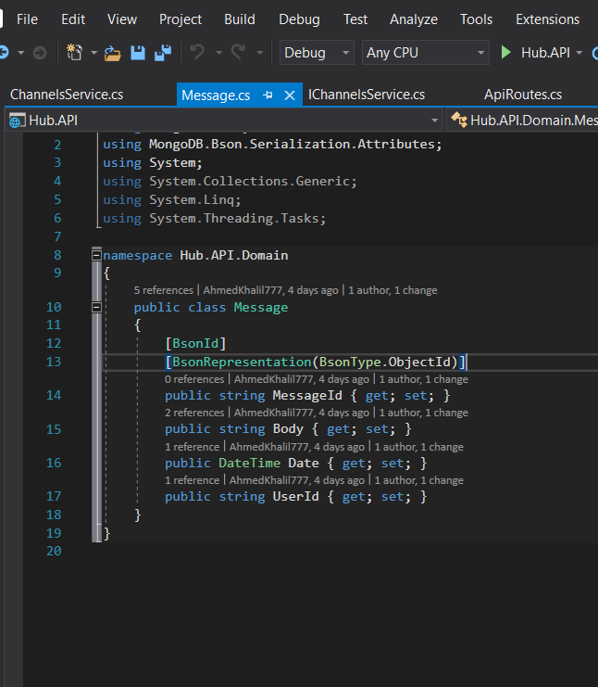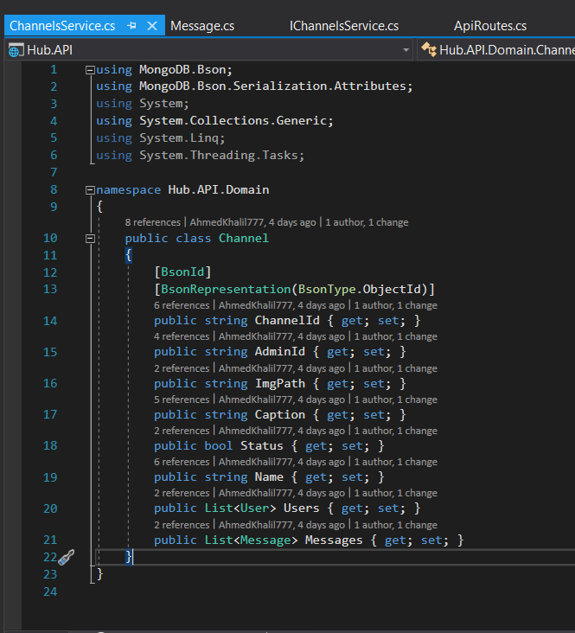

Figure 5.20 The Data access classes to map data from mongo DB

Now, mapping the MongoDB driver to the solution using singleton objects then map the services to create the business logic component to API illustrated in figure 5.21.

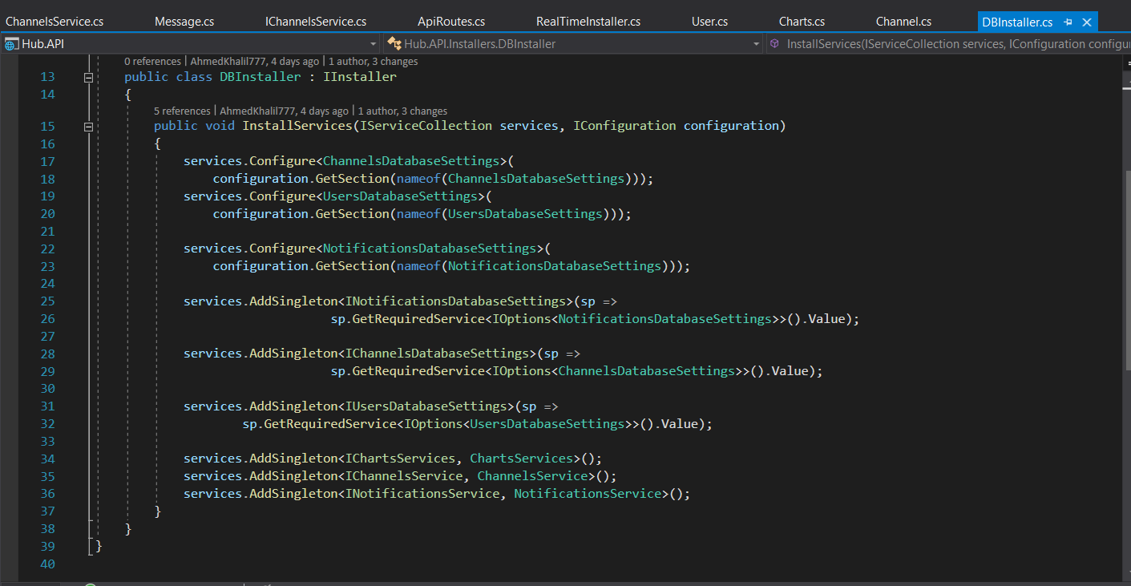

Figure 5.21 Installing DB services of 3 collections and map the Business logic services

##### Business Logic of Chatting development

Creating no the interfaces and the classes to map the logic of every route used, it make a method for every route used by declaring them in the IChannelServices.cs interface illustrated in figure 5.22.

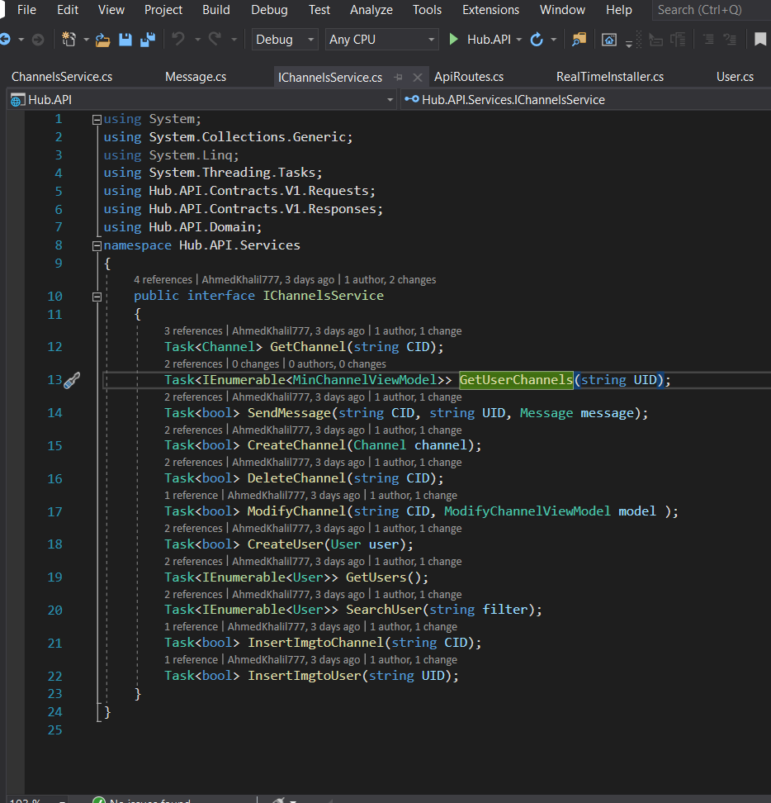

Figure 5.22 Declaring the methods of Business Logic layers

Now, Implement this interface and creating the business logic of it, in class ChannelsServices.cs illustrated in figure 5.23.

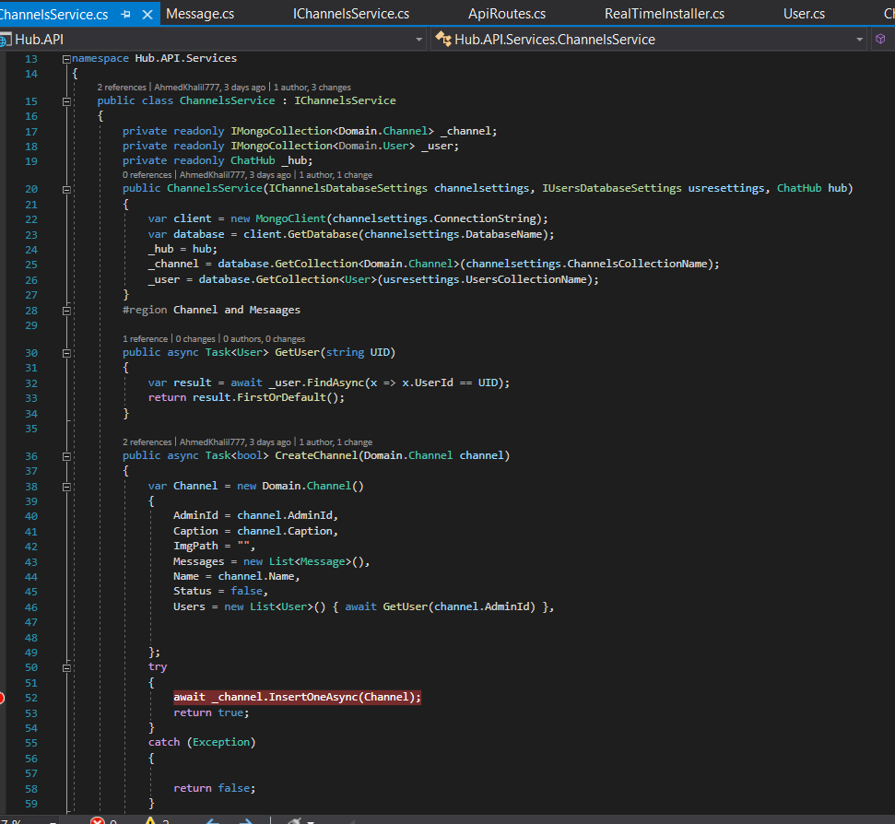

Figure 5.23 Implementation of some of channels business logic

Mapping The controllers to these services using DI design pattern and by creating a singleton illustrated in figure 5.24, then scaffolding a controller then inject the services and calling the business logic and routing shown in figure 5.25.

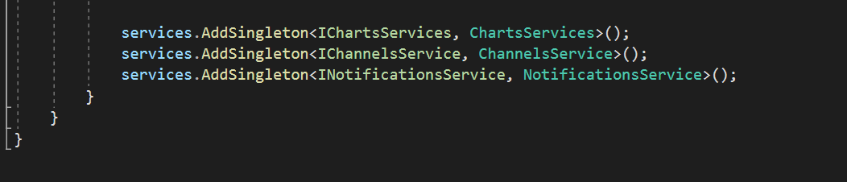Figure 5.24 creating a container as a singleton to inject in controller

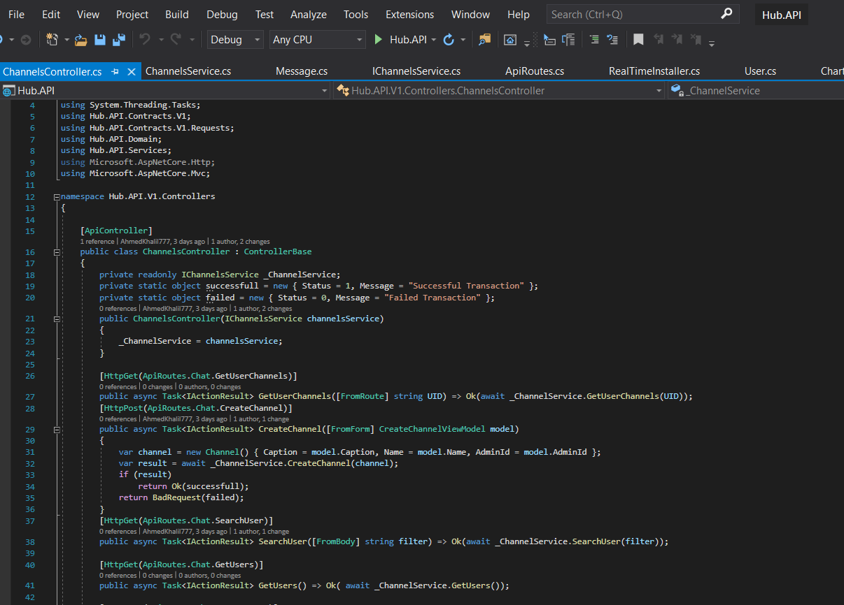

Figure 5.25 Controller to consume the Business logic dependencies

#### Swagger Result of Backend Development

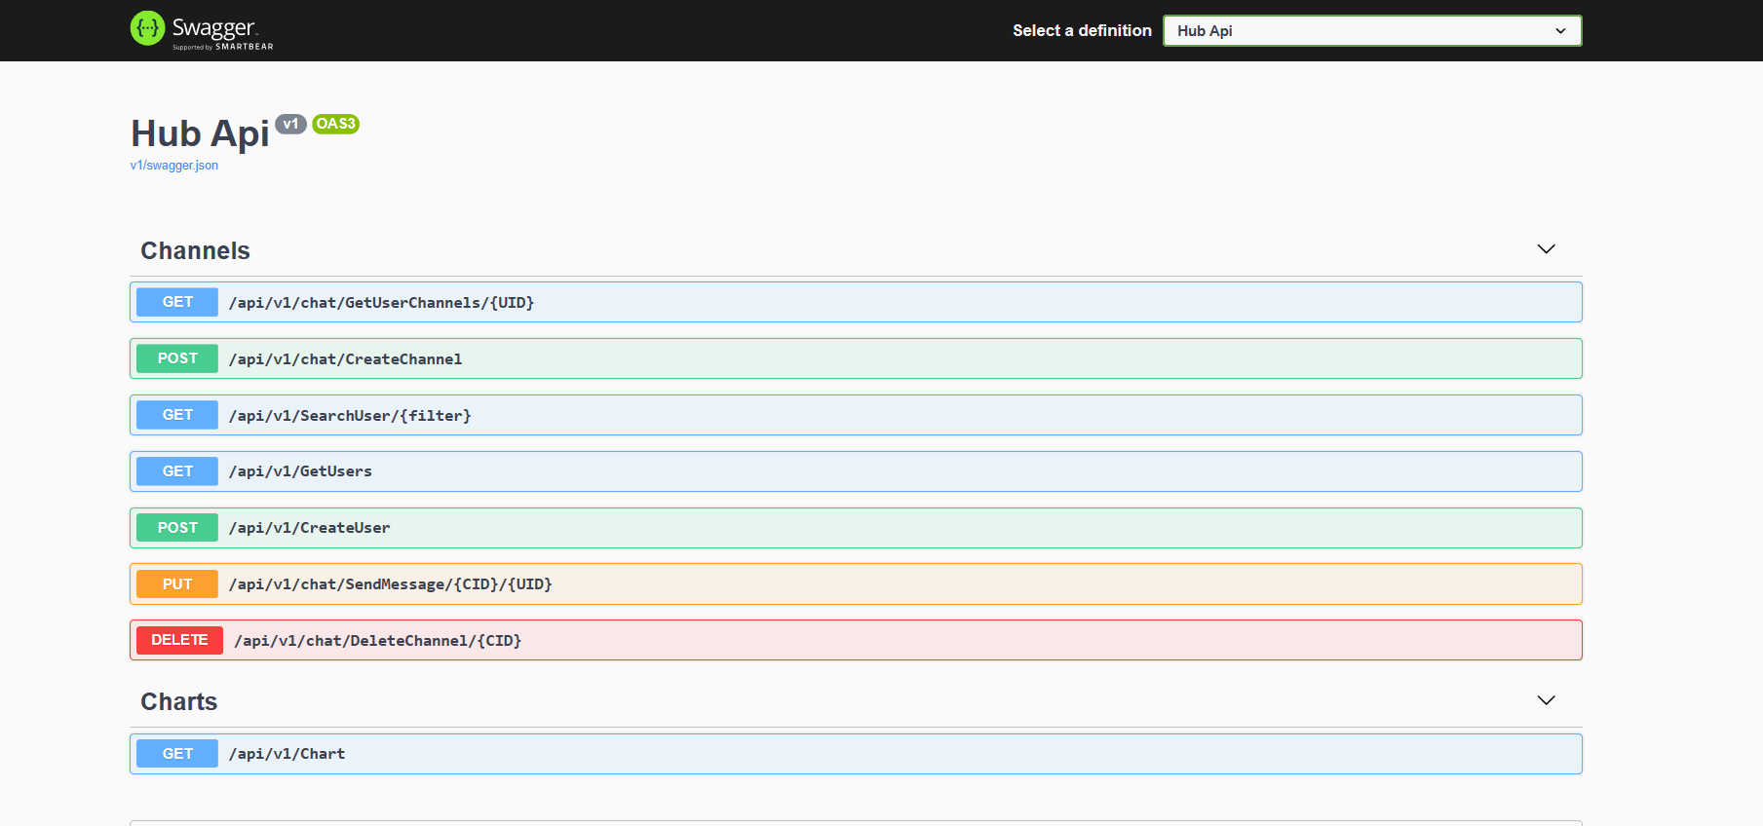

Figure 5.26 Swagger result of Rest API of RealTime App

By implementing the application, The Data can be added once the swagger working, using the Post Http Request to add Users and Channels the Results can be shown in figures 5.27 : 5.

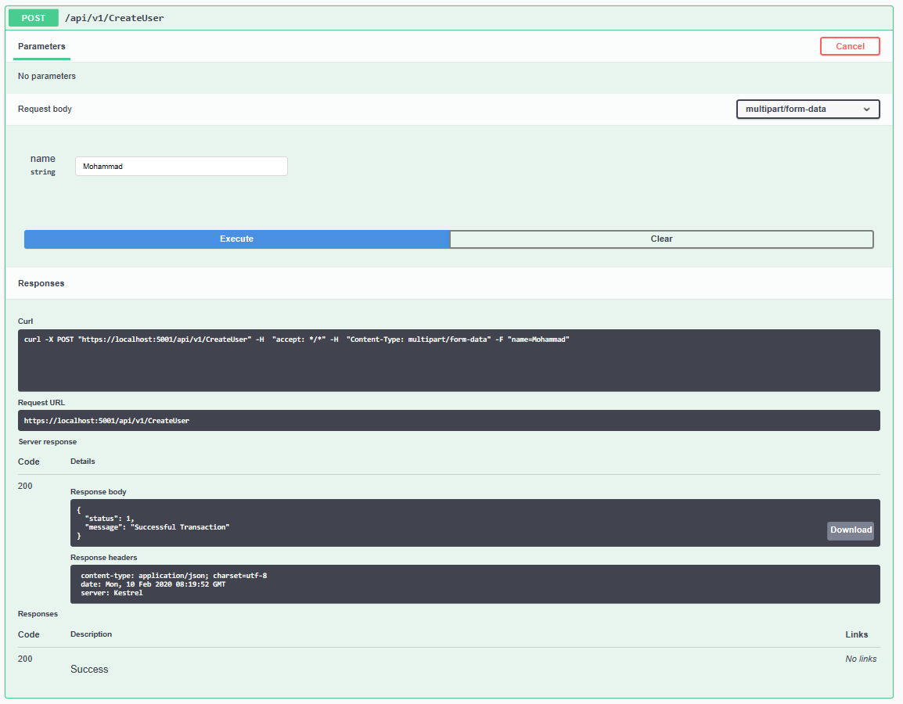

Figure 5.27 Create User by Post Rest API and Saving the Data into Mongo DB

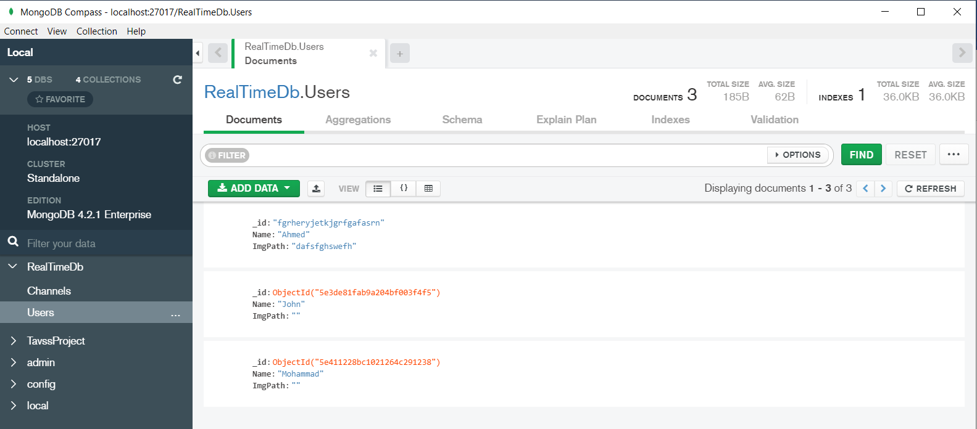

Figure 5.28 The Compass show The Changes of What data be entered

So, Let’s Get These Results

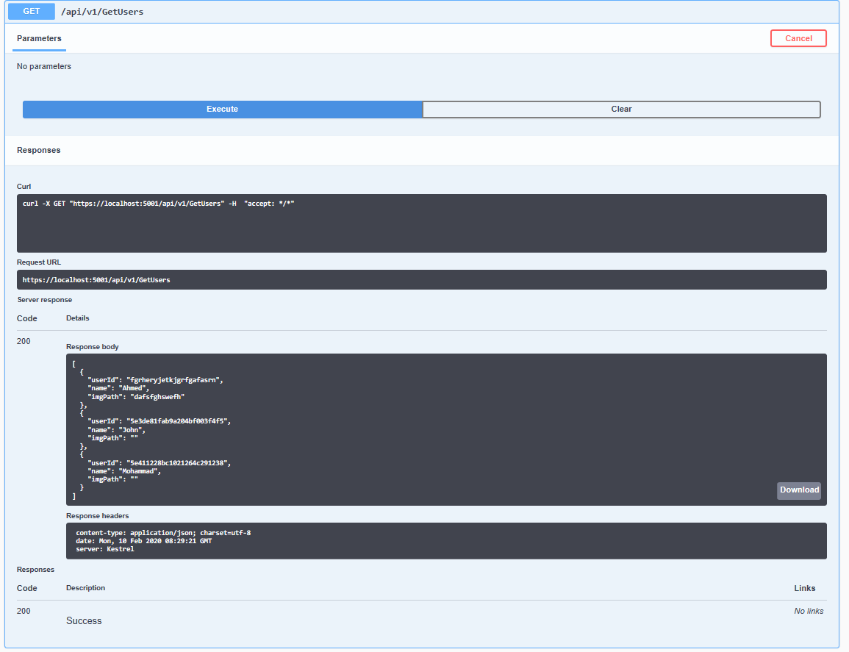Figure 5.29 Getting the Data from Users Collection

It also works for all collections if you need to check them go to clone the github repos and run it:

<https://github.com/AhmedKhalil777/TAVSSonContainers.Hub.API.GitHub>

## 5.3 SIGNALR Notifications Development

## 5.4 Signalr Charts Development

The Charts is a channel to a user that contain large data and preview these data into a graph, make it easy for reports, ease access.

### 5.4.1 Implementing Charts UNIDirectional Channel

First, creating a model that describe the data to be previewed illustrated in figure ………….



This form of data is expected by the Angular Charts library (which is yet to be installed), thus the model properties **Data and Label**.

Let’s move to create the Hub where the connection initiated and used by creating a Hub for shown in figure ………….



Then Mapping ChartsHub as endpoint and create its pipeline showing in figure………



### 5.4.2 Implementing TimerManager

To simulate a real-time data flow from the server, by implementing a Timer class from the **System.Threading** namespace. Let’s create a new folder **TimerFeatures** and inside it a new class **TimerManager** illustrated in figure …………



using an Action delegate to execute the passed callback function every two seconds. The timer will make a one-second pause before the first execution. Finally, just creating a sixty seconds time slot for execution, to avoid limitless timer loop. If you want to learn more about delegates and how to use them to write better C# code, you can visit Delegates in C# article.

It is important to have a method that has one object parameter and returns a void result. The Timer class expects that kind of method in its constructor.

## 5.5 Frontend Angular SignalR Charts Development

After creating The Real Time API, this API must serve the user in real-time mode and to Begin, Let’s launch Angular application as SPA (Single Page Application) that consume all real-time services.

### 5.5.1 Installing Required Packages of Angular from NPM

Install the SignalR library for the client side. To do that, opening the Angular project in the Visual Studio Code and type the following command in the terminal window:

$ npm install -g @aspnet/signalr --save



Then installing the charts of Angular application, a package of responsive charts.

**Angular Charts & Graphs for Web Applications**

Angular Charts & Graphs for your Web Applications. Charts are Responsive & support animation, zooming, panning, events, exporting chart as image, drilldown & real-time updates. AngularJS Application including line, column, bar, pie, doughnut, range charts, stacked charts, stock charts, etc. To top it all off, it can render thousands of data-points without any performance lag.

More information: <https://canvasjs.com/angular-charts/>

Executing now the command to install this package from Node JS Package Manager

$ npm install ng2-charts --save



It seems that the application has some of warnings and starting to solve these warnings, first solving the problem of Karma-jasmine package by install its dependencies

$ npm install jasmine-core@>=3.5 –save

Second installing dependencies of Angular charts using following command:

$ npm install chart.js@^2.7.3 –save

### 5.5.2 Configuring The Apllication to work with new Packages

Adding the JS package to the configuration of angular in file of Angular.json in scripts Array



Then importing the module to app.modules.ts to start to consume them



Of course, the HttpClientModule is not required for the charts to work, but we are going to send the HTTP request towards our server, so we need it.

### 5.5.3 Implementing the SignalR Logic

Let’s Create a service for the sole purpose to wrap the SignalR logic

$ ng g service services/signal-r --spec false



Then generate an interface (ChartModel) to map the resources of the backend logic and implement the 2 properties the Data as Array and The Label as String





By creating 2 folders:

* The first for Interfaces to map data from the server
* The Second is Services to contain the consumed modules logic like (Signalr , HttpContext)

### 5.5.4 Consuming The SignalR Services

First, the module must be imported to its service call it from the node\_modules packages:

import \* as  signalr from '@aspnet/signalr';

the signalr property now containing all SignalR’s modules that can be consumed over application. Then importing the interface ChartModel to map the data into an object created from it.

import { ChartModel } from '../interfaces/chart-model';

Defining Prosperities to consume these modules into class. Making an array of data as ChartModel array and using a hubConnection object that can manipulate the functionality of Signalr.

  public data : ChartModel[];

  private hubConnection : signalr.HubConnection

Starting by configure the connection by the server, declaring what is the IP and which Route can be the Socket in then building in the hubConnection object

    this.hubConnection = new signalr.HubConnectionBuilder()

                                    .withUrl('https://localhost:5001/Charts')

                                    .build();

Now after configuration, Starting the connection and maintain the connection if it’s lost, the log message created.

    this.hubConnection

        .start()

        .then(() => console.log('The Connection started'))

        .catch(err => console.log('There are an error :' + err)  );

Then in ON mode the server sent events data so, Application must capture these data from its pipe using listener to a server, it is strange that a client app using listeners but the rule is one, have the same name of the pipe in the server declared in section 5.4.

  public addTransferChartDataListner =() => {

    this.hubConnection.on('TransferCharts', (data) => {

      this.data = data;

      console.log(data);

    });

The whole service is implemented in figure ……………



### 5.5.5 Consuming Services and RESTful app as a UI

Using now the Dependency Injection to create a separate object that consume these modules of The Service (Siganal-r) and the HttpClient to maintain CRUD vs REST operations.

In the start or The ngOnInit() calling the Initiation and Listening methods then log all responses to console as messages to check illustrated in figure ………………...



### 5.5.6 Building And Testing the Results of Server

First run the Hub.API for a server and the Angular App to check the results shown in figure………..



Now by checking results the Get Method worked successfully and the results is real-time by it changed every 2 seconds declared in the TimerManager => see the last section of the server illustrated in figure………….



### 5.5.7 Design the Charts UI as Canvas To Show Results

Implementing the UIs is a good practice when the Developer practice the Real-Time Services, Now going to consume the Charts Modules of Angular and to consume it, it’s just a canvas of JS and contain some configurations first.

So, beginning to configure the canvas from the TypeScript component it has:

* chartOptions that contain several params like scaling and the point of drawing

  public chartOptions: any ={

    scaleShowVerticalLines: true,

    responsive: true,

    scales: {

      yAxes: [{

        ticks: {

          beginAtZero: true

        }

      }]

    }

  };

* chartLabels is a string array that contain the Labels over x axis required from server

  public chartLabels : string[] = ["Real Time Data for The Chart"];

* chartLegend is a Boolean determine if the chart need a legend section or not.

public chartLegend :boolean = false;

* chartType is a string determine the chart type, so implementing as bars.

public chartType : string = 'bar';

* The Colors of every bar determined by colors as array of CSS elements

  public colors : any[] =[{backgroundColor : '#5491DA' }, { backgroundColor: '#E74C3C' },{ backgroundColor: '#82E0AA' }, { backgroundColor: '#E5E7E9' }];

showing the modification in figure………….

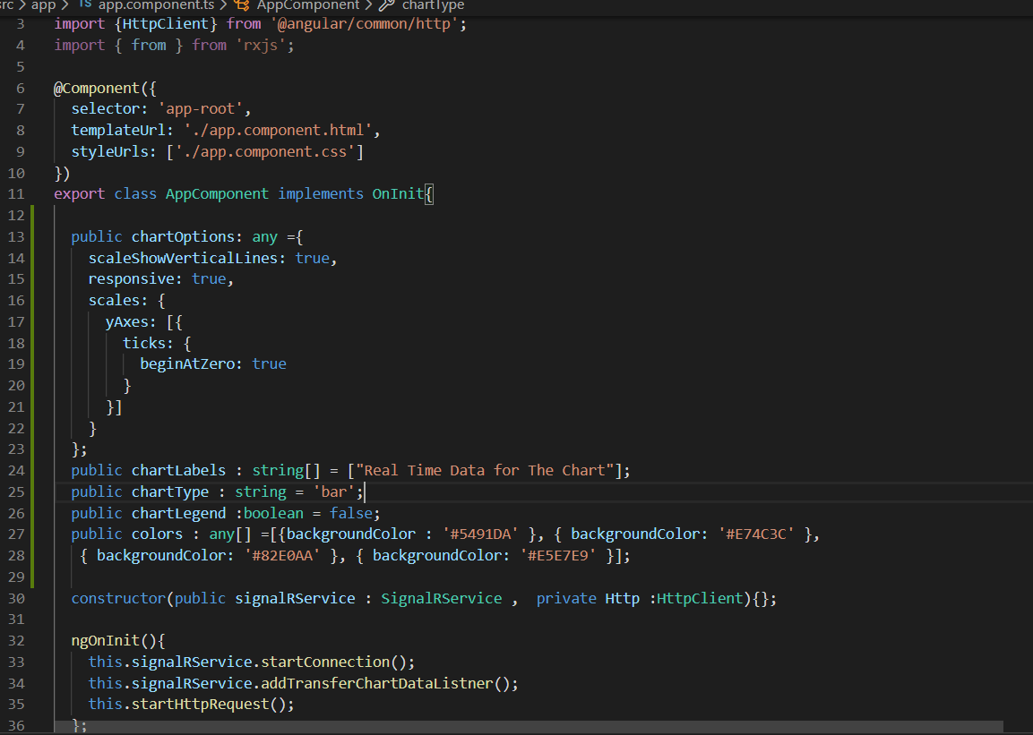

Now creating the Html content to consume the canvas chart showing in figure…………

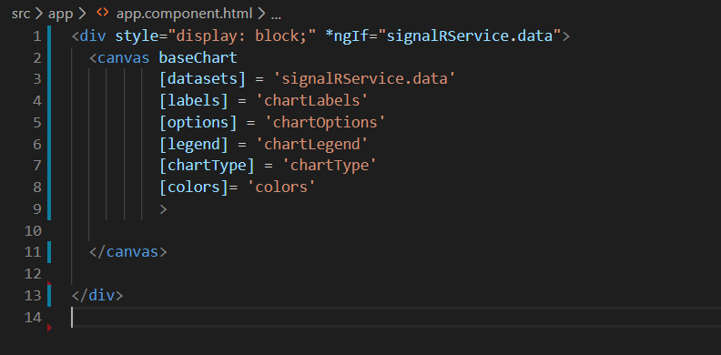

And here is the results of running the server and the Angular app representing the real-time changing of data illustrated in figure ……………

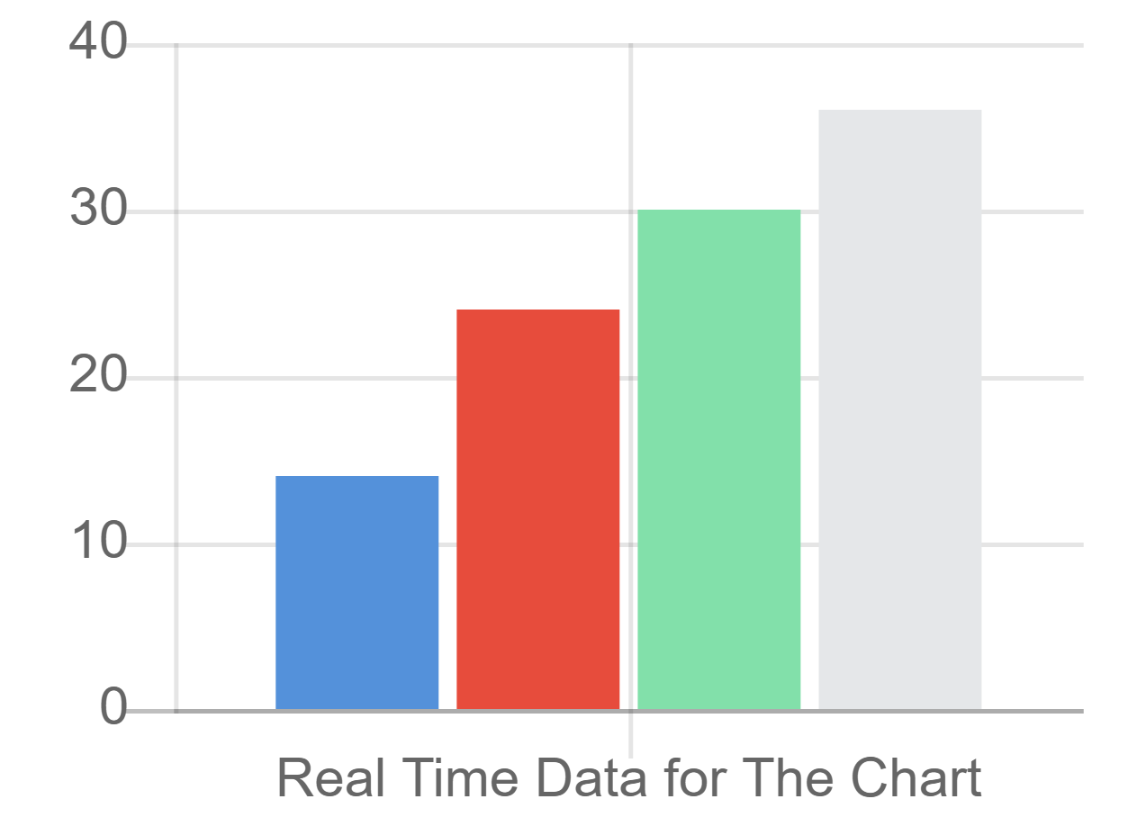

# CHAPTER 6: Integration

# CHAPTER 7: GATEWAY DESIGN PATTERN {BFF : OCELOT}

# Bibliography

1. David Wall, in [Multi-Tier Application Programming with PHP](https://www.sciencedirect.com/book/9780127323503), 2004
2. Prins Carl Santoso, Analyst at Mitrais <https://www.mitrais.com/news-updates/breaking-complexity-using-domain-driven-design/>
3. Cesar de la Torre, Sr. PM, .NET product team, Microsoft Corp, Containerized Application Lifecycle with Microsoft platform and tools 2019.
4. Cesar de la Torre, Bill Wagner, Mike Rousos .Net Microservice Architecture using Containerized Application
5. Dan Shewan, How to Do a SWOT Analysis for Your Small Business (with Examples) , <https://www.wordstream.com/blog/ws/2017/12/20/swot-analysis>
6. Jason Smit Chief User Experience Office, assessing the microservice development using agile approach 2018, <https://dotcms.com/blog/post/what-are-microservices-and-how-do-they-aid-agile-development->
7. Jeff Sutherland, Ken Schwaber, the co-creator of Scrum and a leading expert on how the framework has evolved to meet the needs of today’s business, <https://www.scrum.org/resources/what-is-scrum>
8. <https://www.blueprintsys.com/agile-development-101/agile-methodologies>
9. <https://www.guru99.com/sql-vs-nosql.html>
10. Bryce Merkl Sasaki <https://neo4j.com/blog/acid-vs-base-consistency-models-explained/>
11. José M. Aguilar, Microsoft SignalR Programming in Microsoft ASP.NET {practical Book}